**A report submitted in partial fulfilment**

**of the regulations governing the award of**

**the Degree of**

**BSc. (Honours) Computer Science with Games Development**

**at the University of Northumbria at Newcastle**

**Project Report**

**An Investigation into the Effects and Causes of Frustration in Games**

**Max Stephenson**

**2023/2024**

# Declarations

I declare the following:

(1) that the material contained in this dissertation is the end result of my own work and that due acknowledgement has been given in the bibliography and references to **ALL** sources be they printed, electronic or personal.

(2) the Word Count of this Dissertation is **13,163**

(3) that unless this dissertation has been confirmed as confidential, I agree to an entire electronic copy or sections of the dissertation to being placed on the eLearning Portal (Blackboard), if deemed appropriate, to allow future students the opportunity to see examples of past dissertations. I understand that if displayed on eLearning Portal it would be made available for no longer than five years and that students would be able to print off copies or download.

(4) I agree to my dissertation being submitted to a plagiarism detection service, where it will be stored in a database and compared against work submitted from this or any other School or from other institutions using the service.

In the event of the service detecting a high degree of similarity between content within the service this will be reported back to my supervisor and 2nd marker, who may decide to undertake further investigation that may ultimately lead to disciplinary actions, should instances of plagiarism be detected.

(5) I have read the Northumbria University/Engineering and Environment Policy Statement on Ethics in Research and Consultancy and I confirm that ethical issues have been considered, evaluated and appropriately addressed in this research.

SIGNED: MAX STEPHENSON

# Acknowledgements

I would like to thank my supervisor, Dan Hodgson, for his guidance on this project and his teachings of using Unreal Engine.

# Abstract

The aim of this study is to investigate the causes and effects of frustration within games, using a short 2D platformer game made in Unreal Engine as part of an experiment to get data and responses from subjects who play it. This study links a literature review of psychological theories of frustration with the design of the game, specifically building said game to invoke different types of frustration in order to get a range of responses. Overall, the experiment revealed that frustration arises mostly from repetitive exposure to something that blocks them from achieving a certain goal, and within the context of a game this is most prevalent with designs that are purposely made to be difficult and challenging, as they are the designs that users are most likely to have to play multiple times over.

Contents

Declarations 2

Acknowledgements 3

Abstract 3

Introduction 5

Research and Planning 6

Literature Review 6

Requirements Discussion 14

Experiment Requirements: 14

Game Experience Requirements: 15

Practical Work 15

Design 15

Game Design 15

Experiment Design 16

Implementation 17

Game Implementation 17

Experiment Implementation 31

Testing 31

Analysis and Conclusions 31

Analysis 31

Experiment Analysis 32

Requirements Analysis 34

Conclusion 36

Recommendations for future work 36

References and Sources: 37

Literature Review References: 37

Game Asset Sources: 38

Appendices 39

TOR 39

Terms of Reference 39

Student Project Ethics Approval Form 45

Requirements 58

Experiment Requirements: 58

Game Experience Requirements: 58

Link to Unreal Game Folder 59

Design Documentation 59

Game Design: 59

Experiment Design: 63

Testing Document 64

Post Test Fixes: 65

Experiment Results Documentation 66

# Introduction

Frustration has always been a core part of video games, whether it is by intention or not. This link between game design and player psychology is central to the discussion around frustration in gaming, and how it can influence gameplay, feelings, enjoyment, and motivation.

This study investigated what can cause frustration, and what effects happen as a result of it within the context of a 2D platformer game. The experiment part of the study was designed to investigate how specific aspect of design will affect players, specifically looking at difficulty and glitches – and how players respond to them both physically and mentally by utilising recordings, a survey, and an interview. By examining these responses, this study explored which factors influence frustration the most and which type of responses can be expected from players.

The key objectives to this study were: to understand which aspects of game design cause which types of frustrated reactions; to design and create an experiment which can be used to investigate players responses to frustration; and to evaluate the game and the experiment based on a set of requirements to support my findings. Achieving these objectives not only revealed more about the psychology of game design and how it affects player, but also developed an understanding of how to design an effective experiment around the subject.

Basing the design of the game and experiment on past findings and studies is also an important concept to this study to provide knowledge on the technical aspects of psychology and to explore how they can be interwoven into a game experience. By using prior research and papers, the experiment was designed to reapply that knowledge into a modern look at how they can be applied withing the context of a video game.

The experimental approach of the study involved exposing subjects to varying levels of frustration, using the levels of the game to separate the different types of frustration that will be tested. By tweaking different aspects of the levels – such as increasing spaces between platforms and adding glitches - the study uncovered which aspects of the level design bring about the most prevalent reactions of frustration and explored the connection between the player psychology and game design.

Furthermore, this study contributes to other investigations of similar nature by providing practical reasons as to which parts of the study did and didn’t work, and how it can be improved and expanded on in further studies. These contributions are revealed from analysis of the implementations of both the game and experiment and focus on how the size and coverage of the study can be increased in order to gather a larger and more accurate data set.

# Research and Planning

## Literature Review

**Introduction:**

Frustration, by definition, is the feeling of being annoyed or less confident because you cannot achieve what you want (Cambridge Dictionary, 2019). However, frustration is a much more complex emotional state that can be influenced by several factors and can cause a wide range of both emotional and physical responses. The central core of frustration is an emotion that stems from being unable to achieve something. This is a mostly universal experience for every person within every type of social or cultural area and encompasses many emotional and behavioral responses that can vary on a large spectrum from person-to-person. This review aims to look at both the causes and effects of frustration, how tolerance of frustration is built up, and the effects and reactions to frustration, and review frustration theories.

**Part 1: General Frustration**

**Causes:**

The causes of frustration were simplified into Rosenzweig’s classification system (Rosenzweig, 1934), which aimed to classify the conscious types of reaction to frustration. Extrapunitive frustration causes anger and indignation and usually stems from blaming another party that is not themselves. The individual attributes their frustration upon whoever or whatever they believe is blameworthy for preventing them from achieving their goal. This is usually accompanied by some malice towards that party. The anger stems from the individual subconsciously thinking they could have achieved their goal if it hadn’t been for the party they are blaming – they do not allocate the responsibility of failing the goal to themselves. For example, someone who is late for an event due to traffic will experience extrapunitive frustration, placing the blame on the traffic and will usually adopt an attitude of hostility towards their environment (Rosenzweig, 1935) such as honking the car horn or swearing.

The contrast to extrapunitive frustration Is Intropunitive. This Involves the individual experiencing both humiliation and guilt (Rosenzweig, 1934), placing the blame of their inability to achieve their desired outcome upon themselves. For example, someone having plans with a friend get cancelled last minute may lead to a guilty reaction, placing the blame on themselves under the belief that they are an inferior person to their friend and unworthy of their attention. A study of Rosenzweig’s classification system (Gatling, 1950) suggests that the internalization of aggression is a consequence of the inhibition of the outwards expressions of guilt and remorse.

The third and final classification is impunitive, which is a type of frustration that exhibits embarrassment and shame but neither blames themselves or others, and instead focuses on how to better the situation or overcome it. The individual attempts to avoid blame entirely, not just upon themselves but on anything else too by purposefully glossing over the frustrating situation to make less of a deal out of it. This is commonly achieved by referencing unavoidable circumstances, even at the price of self-deprecation (Rosenzweig, 1934).

Gatling’s study of Rosenzweig’s classification system on juvenile delinquents (Gatling, 1950) focused the system on a specific group of people to see how it may apply to different groups. Between a group of delinquents and a control group, it was much more common for a delinquent to experience extrapunitive frustration accompanied by anger towards someone else. This is likely due to a group like delinquents having many more things in their life to blame, such as parents, the police, the legal system etc. Whereas the control group were much more likely to experience intropunitive frustration. The study hypothesized that the control group would likely become more biased towards extrapunitive frustration if sufficiently frustrated for an extended period.

**Effects of frustration:**

Although frustration is a universal emotion, not everyone will experience it the same way. One of the major effects is an effect on cognitive performance – either positively or negatively. The effect that is obtained is based upon the nature of the needs and actions involved, the strength of the forces involved, and the properties of the perceptual cognitive systems involved (Barker, 1938). If an individual is persistently exposed to obstacles that are causing frustration, it can cause mental fatigue which will reduce cognitive performance. The emotional strain from repeated frustration can also lead to impulsive thinking where the individual does not think through their actions and instead rushes to a choice to try and end the frustration as soon as possible. On the other side of the spectrum, it can also cause decision paralysis where the individual can get stuck trying to make a further decision as they desperately try to avoid yet another cause of frustration from a bad decision.

As suggested in a review of frustration in juveniles (Gatling 1950), extended exposure to frustration is more likely to change how someone reacts to it. This can also apply to the effects of it. Initially, frustration is likely to increase cognitive problem-solving skills, with the frustration acting as an almost encouragement towards achieving your goal. When frustration kicks in, your body temporarily raises the strength of your perpetual-cognitive-motor systems close to maximum levels to compensate for the frustration (Barker, 1938). However, over time an individual’s mental resources will be expended quickly which will lead to a loss in cognitive problem-solving and patience when it comes to figuring out solutions.

**Frustration Aggression Theory:**

A key outcome of frustration is aggressive/unsociable behavior. The key theory on this topic is the Frustration Aggression Hypothesis which was proposed by Dollard et al. (1939) and reviewed and refined by Berkowitz (1989). The hypothesis proposes that frustration leads to aggression, and aggression is used as a cathartic release of the built-up frustration. However, the outburst is not always targeted at the cause of the aggression, as several factors can change who/what the individual targets the aggression at. These factors can include: risk of punishment – if the individual knows they may get punished if they take out their aggression on the source; money – if the source of the aggression is an expensive item or if the outburst of aggression may cause damages that would require money to fix; status – whether the source of frustration is a person of higher status or if the individual could lose status from their outburst.

The main stages of the frustration-aggression model starts with goal interference, where an attempt to achieve a goal is blocked. Next, frustration occurs, and an aggressive drive is created. Finally, cathartic aggressive behavior is displayed. The level of aggression is typically based on how much time the individual has invested into the goal and how close they were to achieving it before they were blocked from it. Two defense mechanisms are used when a cathartic outburst occurs. The first is sublimation, where aggression is used to an advantage. Sublimation stops the individual taking their frustration out on someone/something else and instead uses it to better themselves in some way. This can be something like using your aggression while playing sports to increase your performance or using the frustration to motivate you more into achieving your goal on the next attempt. The opposing defense is displacement, which sees the individual directing their aggression towards someone or something. This can take a wide array of forms such as shouting or physical violence.

Berkowitz’s revised theory on the frustration-aggression hypothesis proposed that frustration does not always lead to aggression, and that aggression would only occur if certain cues were present – it does not manifest as a direct result of frustration. Specifically for aggression, aggressive cues are required for aggression to occur. These include negative emotions such as anger or hostility, or the presence of weapons or dangerous individuals. If frustration occurs without any of these aggressive cues being involved, the likelihood of aggression is reduced massively. This related to Berkowitz’s proposed concept of excitation transfer, where residual arousal from one situation can intensify emotional reactions in another. When relating to aggression, it means that arousal from frustration can increase aggressive responses to subsequent occasions of frustration, even if the source of frustration is not the same.

An experiment to test Berkowitz’s revised theory was conducted by Dill and Anderson (1995) which proved that aggression that stemmed from unjustified frustration – frustration where the individual feels frustrated without a valid or understandable reason – was at higher levels than aggression from justified frustration. They tested a control group and two test groups – one for unjustified frustration and one for justified frustration – by asking them to make an origami bird, by only giving them instructions from an instructor. The instructor would give the instructions only once and would speed up after every instruction. In the control group if asked to slow down, the instructor would slow down. However, in the justified control group, at the request to slow down the instructor would just say he needed to leave quickly due to supervisors being in high demand and he was needed elsewhere afterwards. Whereas in the unjustified control group, the instructor said he simply had personal reasons to leave early. The participants in the unjustified control group rated the instructor as less competent on the ending questionnaire than the control group and the justified group did.

**Frustration Tolerance:**

Frustration tolerance is an individual’s capacity to endure and manage frustration without leading to any impulsive or emotional outbursts. Individuals with higher tolerance can face more setbacks and blocks when trying to achieve something without it affecting their state of mind so quickly. On the other hand, individuals with lower tolerance will find themselves getting easily frustrated at even minor setbacks to their goals. There are a multitude of factors that can affect someone’s tolerance, such as personality traits, cultural influences, temperament etc. A lower tolerance can also be linked to psychological issues like depression, anxiety disorders and aggressive behavior. This shows that the overall tolerance of a person is largely persuaded by the person’s mental state.

The exploration of frustration tolerance and its connection with Internet gaming disorder symptoms (Yu et al., 2018) explores the potential connection between frustration and anti-social behaviors. Internet gaming disorder is a type of behavioral disorder where an individual has impaired control over gaming. The study emphasizes that individuals with lower frustration tolerance may be more susceptible to developing symptoms of social disorders, indicating a link between frustration and specific behavioral outcomes. This shows the importance of recognizing the potential behavioral ramifications of frustration, particularly in the context of emerging issues like Internet gaming disorder.

**Part 2: Frustration in video games**

**Frustration as a deliberate design:**

Video game design has many factors, but the key is player attention. There is no point in creating a game if anyone who plays it stops after the first few minutes. Therefore, players need motivation – something to keep them playing and make them want to continue and finish the game. Frustration is an incredibly important motivator for video games as deliberate frustration is intrinsically linked to the satisfaction derived from overcoming obstacles (Mills et al, 2018). A constant stream of satisfaction is an important outcome of frustration in video games, but the frustration needs to be designed well so it frustrates the player enough that they get satisfaction from overcoming it, but to also not make it overly frustrating to the point where a player either gives up or is too angry to be satisfied upon completion. A method of this type of deliberate frustration is using a skill gap. A skill gap is where the difficulty of a game is increased ahead of the player’s current skills, usually by introducing a new mechanic that the player is not yet familiar with. At first the player will struggle against the new challenge but as you gradually introduce the new mechanics to the player so they can utilize them for themselves, they will close that skill gap. A skill gap acts as a goal that the player is not aware of until they complete it. When they finally do, not only are they satisfied with themselves for defeating the challenge, but they have also improved at the game which provides further satisfaction.

**Frustration from Poor Game Design/Development:**

Frustration can be created because of quality issues in a game. Development issues, server issues, bad game design or software bugs can all create issues for the player that cause frustration due to them getting in the way of the game experience. These can all cause an extrapunitive type of frustration, as the player is blaming the game itself for their inability to achieve their goals. Allen and Anderson (2018) look at the connection between satisfaction and frustration of basic psychological needs. Varying quality issues can compromise these basic needs and thus reduce player satisfaction.

One example is net code rollback. A stable of online fighting games – net code rollback is an important feature for keeping an online match smooth. When the connection between players in a match drops out for just a few milliseconds, it can cause input lag and make it seem like the other opponent is teleporting and can attack without actually moving on the screen. Roll back makes it so that when this does happen, the opponents’ inputs will be ‘predicted’ based on their inputs. This will then be relayed on the player’s screen so even though the connection is temporarily lost, the player can still see what the opponent is doing for those few milliseconds so they can appropriately react. If the actions predicted were not correct, the game can then roll back and show the correct outcome (IGN Southeast Asia, 2022). Properly implemented roll back net code will make the game experience smoother and more responsive for all players and reduce any frustration caused by skipped frames and false inputs. Games without this will be more frustrating to play and retain players less, as they will be constantly frustrated with it, leading to lower satisfaction, and therefore removing any further desire to play the game.

Another example of poor game design being a cause of frustration is with the early generation of home video game consoles. Coming shortly after arcade boom, games made for the early generations of home consoles still based their designs off of arcade style games, that were purposely hard in order to get as many coins as possible from players (How-to-Geek, 2018). Many of these elements made it into the design of home console games. One hit difficulty was a common feature, where instead of a health bar system you would find in most modern games, the player would lose after taking only 1 point of damage, and usually be reset back to the start of the level. This would usually be accompanied by a lives system where you would have to restart the entire game if you ran out. This was due to a combination of being a leftover design of the arcades, as it would be easier to get more coins if the player had to constantly get more lives, as well as the idea that home console games needed to take a long time to complete due to their expensive price. Instead of creating a longer game it was easier and more financially sound for the developers to extend the play time of a shorter game by making the player restart every time they ran out of lives. This is an obviously frustrating issue as the player will be forced to replay the same levels repeatedly, just to get another attempt at the level they are stuck on.

Another source of frustration is the level design of earlier games. For many games, a lot of the difficulty was knowledge based rather than skill based. A lot of level designs consisted of random traps and pitfalls that the player would have no idea where they were until they fell into them. *Contra* (1987) is a notorious example of this, where there are plenty of sneakily placed traps that can immediately kill the player unless the players know exactly where they are before they even appear so they can kill them first. This type of difficulty has no regard for the players’ actual skills, rather it is based on trial and error which causes frustration as the player will always feel useless not matter how good they are – so they are not rewarded for their skill. Furthermore, early consoles like the Nintendo Entertainment System had no internal storage system so there was no way to save your progress, apart from the occasional game which had a small amount of memory built into the cartridge. This means that you had to beat the entire game in one session, otherwise you would have to start again. This causes immense player dissatisfaction as it can mean the only thing blocking the player from the goal of completing the game is not their own skill, but rather that they don’t have hours to play the entire game in one sitting. Creating difficulty that the player cannot overcome just by improving their skills is the easiest way to create extrapunitive frustration and provides little satisfaction from overcoming the goal. Without enough satisfaction from overcoming difficulties, there is no point in creating frustration for the player as it will not motivate them to play the game further.

A somewhat common design flaw of early adventure games is cryptic design that does not equip the player with the right knowledge to complete the presented challenge. The infamous ‘Goat Puzzle’ from *Broken Sword: Shadow of the Templars* (1996) is a key example of this. *Shadow of the Templars* is a point-and-click adventure puzzle game which up until the Goat Puzzle, plays just like most other games of its genre – you select an action (such as speak, move, or picking something from your inventory) and then click somewhere in the game world to perform the action. The unfair difficulty from the goat puzzle comes from the fact that it has the first timed event action in the game, but that is not told to the player. In fact, the player is not even aware that there can be timed actions in the game, as for every other action in the game, another action cannot be started until the first one is completed. To correctly beat the goat puzzle, the player must interact with a piece of machinery quickly after you have agitated a goat to charge towards you. Most players who come across this for the first time would assume they have just done something wrong, not that they need to do something in tandem with agitating the goat. This led to many players getting stuck and stopping playing the game due to not being able to continue. As a result, the puzzle was simplified in the 2009 directors cut edition of the game (Alchetron, 2016). This type of design frustrates the point to the point of quitting due to it not providing any obvious way too overcome it, unlike frustration that come from things like difficulty, where although the player can’t immediately overcome it, there is still a clear route that they must take to do so.

**Frustration from difficulty:**

If implemented incorrectly, difficulty can be the most frustrating part of a video game. When dome correctly however, it can be one of the greatest motivators for a player. In *Dark Souls* (2011) the difficulty of the game is balanced entirely around precise player skill. Enemies do large amounts of damage to you, and you can easily be overwhelmed by even a single enemy. However, by utilizing the telegraphed attacks of enemies and the dodge roll mechanic – a roll that gives a few invincibility frames to avoid damage with – you can beat any enemy in the game without even taking damage. The difficulty comes from learning how the enemies work and when they will use certain attacks. Series creator, Hidetaka Miyazaki, chose this type of difficulty over the regular type of selective difficulty you find in most games released today as he wanted “everyone to feel that sense of accomplishment” when overcoming the initially steep difficulty (Gamepur, 2018). As a result of this design decision, millions of players have purchased and played a Dark Souls game, despite them being much more difficult and frustrating than the average AAA game that is released. The most recent game of the ‘Soulsbourne’ franchise (Demon Souls, Dark Souls 1 through 3, and Elden Ring) called Elden Ring has sold over 20 million copies as of February 2023, since its release in February 2022(Dexerto, 2023).

Balancing in multiplayer games can create an unfair but sometimes necessary difficulty if you are using weapons that are poorly balanced. With most multiplayer games being live services that are constantly updated for up to years at a time, many aspects of multiplayer games will get tweaked to become strong/weaker depending on the usages of weapons and abilities. If you as a player have not unlocked some of the weapons/abilities that the other players have, they might be more likely to lose games due to being at a statistical advantage with their available arsenal compared to those players who have access to weapons/abilities that are currently strongest in the current balancing patch. Kosa and Uysal (2022) found that frustrations from this type of balancing may sometimes be beneficial, as player engagement (which is a necessity for live service games) is largely achieved from the satisfaction of basic psychological needs. When a user gets frustrated from not having the currently best weapons or abilities, they are more likely to keep playing the game in order to earn those weapons or abilities for themselves, which will then create positive satisfaction as not only will they have achieved a long-term goal of unlocking them, but they will also get immediate satisfaction from using them against other players. *Battlefield 4* (2013) used this method at the launch of the game by having some of the statistically strongest weapons as the final unlocks for classes. For example, the Recon class had the SRR-61 Sniper Rifle as its final unlock which had the highest bullet velocity (at the launch of the game) meaning it was the easiest to snipe with and was the most effective at long ranges.

**Frustration from unfamiliarity and controls:**

With so many games being released on multiple platforms, many control schemes are needed. However, some games that are developed for a specific control type (either keyboard or controller) may have difficulty translating the controls onto another controller, which may result in frustrating and unconventional control layouts. This can especially be a problem when creating a port of a PC developed game for console, as a standard controller has a tiny number of buttons compared to a full keyboard. Gerling, Klauser and Niesenhaus (2011) investigated the impact of the player experience on keyboard vs on controller in FPS (First Person Shooter) games, specifically *Battlefield: Bad Company 2* (2010). The study found out that there is little impact on the enjoyability of the game on the different control schemes, as the controller layout was well adapted and did not have any issues that may have caused frustration. Certain genres may have different effects on frustration, as FPS mouse aiming can translate easily to joystick aiming, but genres that are based more on precise pointer controls that would usually be more suited to a mouse such as RTS (Real Time Strategy) games, may work worse on controller. For example, *Age of Empires II: Age of Kings* originally released on PC and Mac but came to PlayStation 2 a few years after release. While it was designed to use the official PlayStation 2 keyboard controller, it was not a common controller for someone to have, so it worked with the regular DualShock controller. The game was not designed with these controls in mind however, so many users were frustrated by the much inferior experience compared to the PC and Mac versions.

To prevent monotony in gameplay, some games attempt to completely switch up the style of gameplay to create a semi-new experience inside of a game you are already familiar with. While this does shake up the standard gameplay loop that has already been established, it can often cause a player to feel disrupted and frustrated after having everything they have learnt be rendered pointless in the face of the new gameplay systems. *Uncharted: Drake’s Fortune* (2007) suffers this during the second third of its story. For the entire game leading up to this, *Uncharted* is a third-person cover shooter with light parkour/climbing elements. However, for two very long chapters of the story you are instead controlling the main character – Nathan Drake – on a jet ski navigating down long streams, avoiding explosive barrels, and having a sparse few combat sections where you are limited to only a grenade launcher while still being stuck on the jet ski. The game replaces its high intensity cover shooting combat loop with a clunkily controlled water vehicle that has one basic weapon that you must be completely stationary to use. In a retrospective of the *Uncharted* series (Jordan, 2016), the reviewer said that the jet ski sections made him “want to cry”. The combination of the poor controls for the jet ski and the rigid combat sections causes these sections to be purely frustrating for the player, making it a part of the game that diehard fans push through with gritted teeth, and makes first time players questions how much they really want to continue the game. On online forums for discussion of the game (GameFAQs, n.d.), many players have expressed their frustration of this section from the games released to the present, where players are still re-experiencing the sections via the 2015 remake of the game. One user expressed their distaste for the gameplay section by revealing that they broke their controller due to the frustration caused by playing through it on a hard difficulty level.

**Ways developers reduce frustration:**

Developers have figured out many tricks and methods to reduce player frustration without them knowing. A common example of platforming games is the ‘Coyote Jump’. This involves giving the player a grace period when falling off a platform, allowing them a short window where they can still jump, even though they are not on the platform anymore (How To Construct Demos, 2020). These helps prevent the frustration a player would get when they miss their jump by just a frame or two, as if they did fail the jump they would be more likely to experience extrapunitive frustration and blame either the game or their controller for not inputting their jump in time, rather than intropunitive frustration as they would only fail the jump if they missed the jump by a large margin, so they would more than likely blame themselves for their error. *Crash Bandicoot* (1996) makes prominent use of this hidden mechanic, as most of the game involves extremely precisely timed platforming. The already incredibly difficult game would be even harder and more frustrating if the player was constantly missing their jumps by a single frame or two.

Potentially the most important aspect of making sure frustration is properly tuned for the experience the developers want, is difficulty balancing. To keep a player engaged with a game, virtual reward systems are common. These rewards players with some kind of in-game reward that will benefit them in some way, such as upgrades or currency. However, some form of difficulty is required for these, as rewards from challenges earned too easily will not be satisfactory to the player. Contrastingly, challenges cannot be too difficult to overcome as the player will become frustrated and stop playing the game (Hendrix et al., 2018). Orvis et al (2008) shows that a player’s experience with games is a powerful influence on how they approach challenges and that the difficulty they face will be massively affected by their previous experiences. This has led to many modern games applying adaptive difficulty systems. *Resident Evil 2 Remake* (2019) tweaks most of the games’ resource systems based on how many deaths and resets the player has had. With more deaths, the player will find more health items, ammo and there will be fewer zombies to face (Game Revolution, 2019). This reduces frustration from less skilled and experienced players by secretly giving them help for them to think they are playing better and remove any potential frustration from them failing even more. Contrastingly, if a player is performing too well, they will find themselves with less ammo and facing more zombies, giving the player just enough frustration to make them feel like they are at a disadvantage, which will then give the player great satisfaction upon completing challenges as they will feel like they have overcome their restrictions.

**Experimental Methods:**

Rosenthal et al. (2008) outlines the key components of experimental methods. One component being the need for dependent and independent variables. A dependent variable is the effect of the experiment, it usually what you will measure to conduct the results of the experiment. Whereas an independent variable is something you will change to affect the outcome of the dependent variable. The value of the dependent variable depends on changes in the independent variable.

Another key component is ethical considerations. The American Psychological Association’s Psychologists Code of Conduct (2002) states that a core principle of ethics in experiments is striving to benefit with those you work with and taking care to not harm them physically or psychologically, and that you should always be aware of the possible effects the experiment could have on a person. It also states you should respect both the dignity and the rights of a person, including the rights to privacy and confidentiality. The code of conduct also lists some Ethical Standards that should be followed. Ethical considerations should also be in line with any ethical concerns from any organizations you may be working with, and any ethical issues that may concern the organization needs to be addressed to said organization. Another standard is considering for personal situations. If there is a likelihood that any personal issues may affect the experiment, then that experiment should be postponed or cancelled until any issues are resolved.

A further key component for an experimental method is data collection. Rosenthal et al. (2008) covers various techniques of data collection such as: observational methods – systematically observing and recording behavior; surveys and questionnaires – administering questions to participants; laboratory studies – conducting controlled experiments in a laboratory setting; field experiments – conducting experiments in the real world outside of a laboratory; qualitive data collection – testers can be interviewed to get a more complex understanding of how they acted. Different methods come with various advantages and disadvantages so methods must be picked according to the experiment that will take place. For example, observational methods may be useful for studying how somebody interacts with a certain object, but it can also cause observer bias, as the data collected is dependent on the person who is observing so their accuracy might not be perfect. Surveys and questionnaires might be good for larger groups of testers, but they need to be worded precisely to get the exact answers you are looking for. Laboratory studies are excellent for doing experiments with accurately controlled independent variables, but they can lack ecological variety. On the other hand, field experiments allow for enhanced ecological validity, but you may have less control over your independent variables. Qualitative data collection can be great for getting more in depth and complex data from testers, but the analysis of their words is always going to be subjective and can often be generalized. Rosenthal et al. states that the choice of a particular method should align with the research goals and the strengths and limitations of each technique.

Another crucial aspect for an experimental method is the proper design of the experimental procedure. The design of the experiment determines the overall structure and organization, dictating how variables will be manipulated and measured. Different designs, such as within-subjects (where the same group experiences all levels of the independent variable), between-subjects (where groups are assigned to different levels of the independent variable), and factorial designs (assigning each combination of the independent variable to a separate group), each come with unique advantages and disadvantages. For instance, a within-subject design allows for direct comparisons between every tester. On the other hand, a between-subjects design reduces the risk of order effects but potentially introducing variability between groups. Factorial designs enable researchers to study the interaction between multiple independent variables. The choice of experimental design depends on the specific research question and the desired level of control over external or unwanted variables. Rosenthal et al. (2008) discusses the importance of thoughtful experimental design, as it directly influences the validity and usefulness of study findings. It is incredibly important that you carefully consider the trade-offs and select a design that fits best with the experiment’s objectives and constraints.

**Conclusion:**

In conclusion, frustration is a key emotion in both daily life and in video games. Whether it is a result of being blocked from a certain goal, or as a deliberate design choice in a game, it can influence a person to react and respond in various ways. As researchers and developers explore further into understanding and prevention of frustration, new developments and theories create new ways to enhance user experiences, keep player engagement high, and develop the understanding of the complex link between frustration and satisfaction, and how it can be manipulated to be used to a positive effect.

## Requirements Discussion

*See Appendix for full list of requirements.*

### Experiment Requirements:

The experiment will follow strict requirements to follow the University ethical guidelines and to ensure any data collected is accurate. The first point is covered by having both a consent form and a debrief form. The consent form outlines the guidelines of the experiment to ensure the subject is correctly informed of how their data will be used, and that they can back out at any time. The experiment itself will focus on measuring frustration levels by using defined dependent variables that specifically target any responses the subjects give to any of the independent variables of the experiment. The interview is the key requirement to getting accurate and detailed results, as it allows me to create a conversation between myself and the subject so I can ask follow-up questions and get lots of specifics about the frustration they felt. Furthermore, the need to limit external factors to maintain a constant and undisrupted test environment is crucial in getting accurate results, so requirements for a quiet test environment and a working computer to run the game on are critical.

### Game Experience Requirements:

For the game experience, it is a simple 2D platformer made in Unreal Engine, as it is an engine I have experience with and know how to use effectively. It also has lots of useful tools for creating 2D games such as sprite sheets and Paper2D objects. The game has 3 levels, the first being a standard platforming level, the second being extremely hard by spacing the platforms apart, and the third being purposely glitchy. 3 levels allow me to cover the two most important classifications of frustration that I want to explore, extrapunitive and intropunitive, leaving the first level to be a warm-up level to get the subject used to the game. As I want to keep the focus on the frustrating aspects of the levels, the controls are extremely simple in order to keep them being distracting or frustrating. This applies to the visuals, which are kept simple but still pleasant to look at, as to not make the entire game boring for the user which could negatively influence how they react to it. The metrics used to analyse the frustration with are built into the levels, allowing tracking for time and death counts which are important for the post experiment analysis to be used alongside the interview data. All these requirements are important to create a controlled game experience where they player experiences frustration at only the designed times and not from any external factors that could mess up the collected data.

# Practical Work

## Design

### Game Design

*The full design document can be found in the appendix.*

The level design across all three levels incorporates three types of enemies and eight moving platforms, divided into two sections with the second acting as a checkpoint to prevent repeating the initial section upon death. This is in an attempt to avoid any undesigned frustration in a scenario where the player keeps dying to enemies – this stops them having to redo the whole level every time which is not a type of frustration I am looking to purposely cause.

Each level features a balanced mix of vertical and horizontal platforming challenges. This is simply to prevent the platforming becoming too monotonous, plus it is mixing up the jumping challenges. The moving platforms follow a back-and-forth pattern, with adjustable endpoints and speeds to diversify difficulty, notably increasing in speed for the second level. This makes the platforms extremely hard to jump on, requiring an extreme skill in precision and timing. This will hopefully be the most frustrating part of the second level.

Similarly, enemies move within fixed areas, posing as lethal obstacles that require precise timing to avoid, also accelerating in speed for heightened challenge in the second level. They are the main obstacle that the player will face in the second half and should be the biggest point of frustration across all 3 levels as a whole.

Level 1 offers generous spacing for jumps, allowing players some leeway when making jumps. This levels intention is to not specifically invoke any type of frustration and act more as a short practice before the other 2 levels. Specifically, its purpose is so the subject understands the level design, as I don’t want the frustration from not knowing where to go influencing or building on top of the other types of frustration in the

Level 2's platforms are spaced apart so the decent amount of leeway in level 1 is completely gone, now instead requiring an almost perfectly precise jump to reach the next platform. However, the first couple of platforms are not as precise as the remainder, in order to show the subject that the jumps actually are possible. Once this seed is planted in their minds that it is possible, the rest of the level should incite intropunitive frustration – where they start blaming themselves for not being able to make the jumps as they now know it is possible to complete.

Level 3 reintroduces level 1's design but incorporates three glitches affecting player movement: lag, occasional missed inputs, and game time slowdowns that simulating game performance issues. These glitches add an additional layer of complexity and unpredictability to the gameplay experience. The predictability is key in trying to invoke extrapunitive frustration, as removing the skill of prediction will theoretically move the blame of failing a jump or dying to an enemy towards the game, rather than the player themselves.

### Experiment Design

*The full design document can be found in the appendix.*

The experiment begins by informing the participant that it aims to test the effects of level design. Participants are seated at a computer and shown the game's main menu, which includes three levels labelled simply as level 1, 2, and 3 to conceal the frustration aspect. It is important that the subject doesn’t realise it is about frustration as it would make them aware of their frustration throughout playing the game, which would likely lead to them over thinking their reactions and how they present their frustration – which would give improper results.

Before starting, participants are briefed on the experiment's procedure, informed of their option to withdraw at any time, and told that their feedback will contribute to a dissertation. The experiment is filmed to capture physical reactions such as aggressive keyboard use or expressions of anger or frustration. It is important to film the subjects as people are not often aware of what subtle reactions or expressions they are making, and therefore will not be able to remember them if asked to recall during the interview. With a recording it is easy for me to go through the footage and simply note what they did for the experiment

After the game, participants complete a Google Form survey and participate in an audio interview. The survey includes questions rating enjoyment, difficulty, and frustration levels for each level on a scale of 1-10, along with inquiries about which level was most enjoyable and any encountered challenges. The interview asks about what the most challenging aspects of the game are, what emotional reactions they had during play, if there were any moments where they wanted to quit, and their view of the game's balance of enjoyment and challenge. Not all of the questions are directly asking about frustration which is by design. I don’t want the subjects realising the study is about frustration until after the interview, so some red herring questions are there too. These can still be useful however, particularly the ones about difficulty as the results may show a link between frustration and difficulty in some way.

## Implementation

### Game Implementation

#### Tutorial Setup:

**Tile set and Tile maps:**

First, using the tutorial I downloaded a free to use sprite package and used the tile set from that. To make it usable for my game, I added colliding tiles for the sprites I will use for the ground tiles. This will allow the player character to walk on them. I then created a few tile maps using the tile set, mostly for different types of platforms that will be used in the level creation.

**Player Character Creation:**

I used the tutorial to set up the basics of my player character, including sideways movement and jumping, making the player sprite face the direction of movement, and attaching a camera to follow the player. Using the sprite pack, I created flipbooks for the various player animations such as idle, running and jumping.

The player movement is done using Axis inputs (A, D, Left and Right Arrow). The Unreal character movement class (CharMoveComp) is used for the variables for the movement such as walk speed.

Jumping is managed by the Jump class within CharMoveComp, triggered by the space bar.

For the movement-based sprite changes, it checks the velocity of the player character, and if it is greater than 0 (0 is when the player is completely still), it changes the flipbook of the character to the running one instead of the idle one. There is also another check to see if the character is in the air using the Is Falling component, and this changes the flipbook to the jumping one.

For the direction-based sprite changes, I created a function which also checks for the characters velocity, but instead checks if it is higher or lower than 0, if the velocity is above zero then the player is moving to the right, so the sprite is rotated to the default Z axis of 0 degrees. If the velocity is lower than 0 then the player is moving to the left, so the sprite is rotated 180 degrees on the Z axis to flip it to face left.

**Initial Game Settings:**

For the last part following the tutorial setup, I created a blueprint to make a game mode for my side scroller. This didn’t require much tweaking; the only change was making the default pawn class to my player character blueprint. In the project settings, I set the game mode to the custom blueprint.

#### Own Work:

**Background:**

My first step was to set up a Parallax background, meaning the background appears as if it is following the player, always keeping it in view without having to make a long texture. I attached the background sprite to the camera in the player character blueprint. This essentially means the background is always going to be perfectly positioned behind the player’s sprite, giving the impression that it isn’t moving at all.

**Player Tweaks:**

For Sprite Character BP, I adjusted the step height to stop the character teleporting onto small blocks, changed the walk and jump velocities and changed how much air control you have.

**Falling off the level:**

If the player character falls off the level somehow, to prevent them from falling indefinitely, I created a function that checks the Z axis level of the player, and if they go below that, it teleports them back to the start of the level.

**End of level goal:**

For the end of level signpost I added a collision box to detect when the player character overlaps with it. As a placeholder, all it does is make the text: “You Win!” appear above the sign. When I get further into the project and create the level menu and end screens, these will be used here.

**Moving Platform:**

My next goal was to create a moving platform that will be a common part of the platforming challenges. I created a sprite in the blueprint and then added the IntertpToMovement component, which allows me to move the objects around. The movement is done using control points. Instead of adding these manually so they would be at a fixed position, I set them up in the construction script and used a Vector Variable for the desired position I want the platform to move to. By enabling the option in the variable to show a 3D widget, it allows me to manipulate the end point of where the platform moves inside the map editor. I also made it so that the Duration of the InterpToMovement (the speed of the platform) was a variable too so it each platform placed can have its own speed.

However, due to a problem with Unreal, the tile map component does not launch upon the start of Unreal, so every time Unreal is closed and re-opened, the tile map disappears and has to be manually reselected. A work around I found was to set the tile map of the moving platform using the Event BeginPlay node in the Event Graph. However, this only works when playing the game and not in the editor. For this, I added a flat cube that covers the area of the floating platform and set it, so it is not visible in game. This way I can see where the platform will be before the tile map is loaded in game.

**Main Menu:**

For the main menu, I created a Widget Blueprint which contained a layout of buttons, one for each type of level I will make. I then created a new blank level for the main menu to use. In the level blueprints I made it so when you press play, it created the widget and adds it the viewport.

To make the buttons open the levels, I set an On Clicked function to each of them which leads to an Open Level function.

The mouse cursor is always visible on the main menu.

**Music and Sound Effects:**

I added a looping music track to my main menu, and a different track for the levels.

For the death sound effect, I create a small function to stop it running every frame when in contact with an enemy.

**Jump Tolerance:**

A common feature in platforming games is a jump tolerance (sometimes known as a coyote jump), which allows the player a brief window to jump even after falling off a ledge. This gives the player a slight bit of wiggle room when it comes to getting a jump in at the last few frames before they fall off.

To do this, I created a Jump Tolerance function to set a Boolean to true for the first half a second of falling. This is done using the event OnMovementModeChange which detects any change in the type of movement of the character (i.e. if the characters movement status changes from walking to falling). Then, in my Jump function, I created a new branch with a custom-made jump using Launch character (as the regular jump function is set to not work while your character if falling) and made it so it can only activate while the Boolean is true.

**Eagle enemy:**

Next, I created the eagle enemy that is a hazard to the player, it uses the same blueprints as the moving platform to allow it to move and become a harder obstacle to avoid. When the player collides with the eagle, I want them to die and respawn. I kept the function inside of the SpriteCharcter BP so the only code in the eagle blueprint for player interaction is to update the isDead Boolean.

Inside SpriteCharacter, I created the dead and frozen Booleans. Dead is for when the player dies, and frozen stops the player moving or jumping while dead. When the player dies, the sprite is hidden and their velocity is set to 0,0,0 and their movement is frozen. Then, a death effect flipbook is made visible for 0.3 seconds for visual feedback to the player that they have died. That flipbook is then hidden again, the actor location is set to the respawn point, the sprite is made visible again and the two Booleans are set to false.

**Layout and decoration:**

The above image is the layout for the regular version of my platforming level. It is split into two sections, one being just platforming and the other having both platforming and enemies to avoid. They are split with a wall that cannot be jumped over. When killed by an enemy, you will respawn at the start of the second section (except in the second level with purposely designed frustration). The level makes use of both static and moving platforms.

**Purposely designed level layout:**

For the level version that is designed to be purposely frustrating, I have made tweaks to the platforms and all the moving objects. All of the platforms have been shortened in some way, most of them down to a single 1x1 block. Moving platforms have been reduced to being 2x1 and now move twice as fast. The eagle enemies also move twice as fast.

The positioning of the platforms has also been tweaked, to make it so that most of the jumps require the player to have jumped at the last moment, giving them very little room for error.

**Unique character properties for glitched level:**

To have a unique character blueprint to use for the glitched level version, I duplicated the regular blueprint, and also made a duplicate of the game mode blueprint and then added that new blueprint as a game mode override on the level, meaning that level with use that blueprint for its game mode settings, rather than the regular one. This allows me to change the pawn that will be used for the Player Start to the new duplicate blueprint.

**Glitchy level properties:**

For the glitchy/unintended frustration version of the level, I am using the same layout from the normal level. I am adding features to the character blueprint to make it seems like there are various bugs or glitches that make the game harder to play.

**Random slowdown:**

One of the effects I wanted to achieve is random slowdown, where the game will suddenly run extremely slow for a short amount of time and then suddenly try to catch up, which throws the player off whatever they are doing.

It works by creating a delay that lasts between 5 and 15 seconds. Then, the game speed is reduced to 60% for a short random amount of time and is then set it to 140% for the same amount of time. It then resets back to 100%. The function calls upon itself to repeat once a loop is done.

**Random lag teleports:**

The next effect I wanted to make was a way to replicate lag. This being where occasionally, you are teleported back by a few frames/seconds depending on how bad your connection is. As I am not using a server or any online connectivity, I am creating a function to replicate it.

First, there is a similar random delay, this time between 5 and 20 seconds. Once the delay is done, it gets the current vector position of the player actor, and then initiates another delay, this time just for a few fractions of a second. The player is then teleported to that vector that was just gotten, meaning the player is teleported to the position they were in a few fractions of a second ago.

**Misinputs:**

When creating the misinput part of the glitchy level, where occasionally an input won’t register, I quickly realised I would need to remake the movement system as the Axis mappings method constantly returns a value every game tick, making it hard to get a count of how many times an input had been pressed.

The first fix for this was changing the movements to Action mappings rather than Axis mappings. This returns a single input when pressed.

I then had to make the movement left and right into input Action functions. This is combined with a simple movement function to check how many inputs there have been, and upon reaching the 7th input, the movement does not commence, and the counter is reset to 0.

The function checks if the Misinput variable is less than 7 upon the button press. If it is, then the RightPressed Boolean is set to true, which commences simple movement using Add Movement Input. If Misinput is not less than 7 then the Boolean is not set to true and Misinput is reset to 0.

I also added a further check for Misinput within the OnTick function, as I found that without this, if you pressed the buttons very fast, Misinput would increase faster than the check and could sometimes go above 7.A screenshot of a computer

I then added this code to the jump function to, making it count as an input.

**Timer:**

To create a timer with an in-game widget, I used a tutorial to help set it up: <https://www.youtube.com/watch?v=xtLrLaWBaiU>.

First, I created a new widget that would display the minutes and the seconds of the timer.

Next, I created a new blueprint for the timer. It uses the OnTick function with a 1 second delay to count the seconds, and when the seconds is greater than 59, the seconds are reset, and the minutes are increased by 1. There is also code to create the widget upon the beginning on the level.

To link the widget and the blueprint, I created a reference to get all the actors from the timer blueprint. This reference is then used to grab the seconds and minutes, convert then to strings, and then update the number on the widget.

**Level Finish Screen:**

Finally, I created a Level Win widget which pops up when you collide with the finish line. It uses the same code as the Timer widget to get the minutes and seconds and displays them on the widget.

The Level Win screen has a button to return you to the main menu.

### Experiment Implementation

The experiment took place over the course of 2 weeks. During that time performed the experiment with 15 subjects, using a quiet room on campus that had just us in it. I first made sure this room was quiet and mostly soundproof, which it was. The room was also cool in temperature, so heat did not affected the frustration in any way.

First, I let the subject read over and sign the consent forms and then briefed them further on the game. Using my laptop, I let them play through the 3 levels at their own pace, with me marking down their times for each level. The subject’s face and hands were recorded while playing.

After the game, I first got them to fill out the questionnaire. After that, I conducted the one-on-one interview where I made sure to ask them follow up questions if their answers were short.

Upon completion of the experiment, I gave the subject the debrief sheet and further informed them of the true intention of the experiment. None of the subjects wanted to rescind their data.

After testing every subject, I wrote up transcripts of the audio interview, wrote notes of important information such as verbal reactions or particular physical actions from the recorded video. Finally, I got graphs of the questionnaire results from the Google Form I used.

## Testing

*Testing document in appendix*

Multiple tests were conducted on the game to ensure all the systems functioned correctly. Any test that failed were looked at to figure out why it wasn’t working and then fixed inside Unreal Engine. It’s important to make certain that the game is robust and will not produce any major errors while the subjects are playing, as it would have an unwanted effect on the subjects experience which could affect the results and data.

# Analysis and Conclusions

## Analysis

### Experiment Analysis

#### Survey Analysis:

Looking at the enjoyment graphs, it’s clear that level 2 was the most disliked level. However, there is not a clear difference between the enjoyment of level 1 and 3. Level 1 has a more compact grouping with the majority of subjects giving it an 8 for enjoyment. Level 3 however has a wider grouping with a bias towards enjoyment, with 3 people giving it a 1 or 2 rating, but also 4 people giving it a 9 or 10 rating. The rest of the subject all rated it between a 5 or a 7. This seems to show that despite the added frustration from the glitches, quite a few subjects found them fun and a nice little added challenge, without it being insanely more challenging like with level 2. This also seems to be supported based on the comments left in the ‘Other’ section of the challenges and difficulties of the level. Some comments mentioned that the glitches made the level more challenging in a fun way. Just from this it seems to hint that most of the subjects preferred the challenge added from the glitches than the challenge from making the platforming harder.

Interestingly, when linking these results back to the literature review, it seems that the frustration created from the glitches seems to fall into the impunitive category (frustration that exhibits embarrassment and shame but neither blames themselves or others) rather than extrapunative (frustration that causes anger and indignation and usually stems from blaming another party that is not themselves) like I had intended. Rather than blaming the game itself from being glitchy or broken, most of the subject accepted it as part of the game and considered it part of the challenge of completing the level.

However, this reasoning could also be due to how the different types of frustration affected the difficulty. Comparing the graphs for how difficult the subjects found level 2 and 3, level 2 is almost unanimously voted as the hardest level, with everyone voting it at a 4 or below on easiness, with only one outlier giving it a 7. Comparatively, level 3 has at least 1 vote for each rating except 10, with the most giving it between a 5 and an 8. It appears that the added challenge from the purposely created frustration wasn’t equal to the challenge that came from the difficulty increase - and that the latter made the level far more unenjoyable. It also seems that the frustration itself wasn’t a factor in the increase of difficulty either, as the graph show that both levels received a majority of high frustration scores.

I believe these results are due to the fact that the difficulty increase from the altered level design with bigger jumps and faster platforms was a more consistent change than the randomness of the glitches. Although both levels were more or less equally frustrating in design, the frustrating design for level 2 is constant, as the platforms are always further apart, and the platforms/enemies constantly move faster. On the other hand, the glitches in level 3 only occur sporadically, and depending on how the player is playing they may not even take effect (e.g. if the player has been stood still preparing for a jump, if the lag glitch that teleports them back a few milliseconds happen, the user will not notice any effect). This leads me to believe that the effect of frustration creating a high level of difficulty for the player may only have a prominent effect if that frustration is reoccurring frequently over a longer period of time.

Furthermore, it seems that frustration was not the key deciding factor in overall enjoyment, as level 1 and level 3 were tied with being the most enjoyable overall level. From this it can be inferred that intropunitive frustration (frustration causes anger and indignation and usually stems from blaming another party that is not themselves) has the strongest negative impact on enjoyability of a game, whereas impunative frustration can actually be a strong factor in increasing enjoyment of a game.

On another point, looking at the responses for encountered challenges or difficulties on level 2, some of the answers support Rosenzweig’s classification system for frustration, specifically intropunitive frustration. Two of the responses specifically mention inexperience as the core challenge of the level. The responses are specifically blaming themselves for the challenge, not necessarily the difficulty of the level. This backs up my literature review in supporting the fact that skill-based difficulty increases cause intropunitive frustration, and usually make the player blame themselves rather than the game. This however is not factoring in other aspect of difficulty, such as how and when the difficulty increase applies, how big of a spike in difficulty it is or which aspect of the game design the difficulty increases. This aspect of research is beyond the scope of the experiment but could but researched in the future.

#### Game Reaction and Interview Analysis:

Firstly, looking at the times, it is clear that level 2 took most people the longest, usually by a large amount. It was also not finished by 8 out of the 15 people that played it. From the interview it is also clear that it was the most frustrating level out of the 3. These could reveal two possible meanings: that time is an important factor of causing frustration, and that one of the main causes of frustration in gaming is making people give up.

To expand on the first point of time being an important factor for frustration, some of the interview results support this too. Many of the subjects more extreme reactions such as cursing, or having physical responses to it, only usually happened at around halfway through their play time of level 2. It shows that frustration is not something that can just happen at an instant, it needs to be built up to. These reactions from the subjects point towards the initial build up to the point of frustration as possibly the most important part of causing frustration, rather than the direct incident which creates it. From watching the subjects play and how they react, it became clear that even parts of the levels that most players found fun can still be frustrating to someone if they have had a few moments of smaller frustration beforehand.

Furthermore, I believe the results also show that repetition is another factor in causing frustration. Subject 14, for example, remained mostly calm and concentrated on level 2 until they got stuck at one particular jump. After multiple attempts of the same jump – that’s when most of their reactions began to show frustration. The results seem to show that level 2’s difficulty isn’t the direct cause of frustration, but rather the fact that the higher difficulty required people to keep attempting the same sections over and over again, constantly having their progressed halted and restarted. This directly correlates with the core definition of frustrated that was explored in the literature review – that frustration is the emotional result of not being able to achieve something, which in this case is the achievement of getting to the end of the level blocked by difficult platforming.

As for frustration causing people to give up, the results showing that over half of the subjects gave up during level 2 supports the idea that frustration – especially repeated frustration – kills desire to play the game further, rather than encouraging them to continue playing. This contrasts my findings in my literature review where past studies and research explained that often times frustration is a motivator. From the interviews a few people who didn’t finish the level said it was because they were stuck on a particular part and didn’t think they could finish it in a reasonable time. However, the flaw to this finding is that the are possibly other external factors that might have caused them to give up also, such as feeling like they are not supposed to keep going for a long time, or that they don’t want to use up a large amount of their free time participating in an experiment.

Similarly to the results from the surveys, the results here support that the glitches in level 3, that were designed to cause extrapunitive frustration, instead caused impunitive frustration. Lots of the reactions included laughing, and very few people showed annoyed or frustrated reactions while playing it. Then during the interviews, a few people said that they found the glitches amusing and added a fun challenge. These reactions create the impression that the extrapunitive frustration can instead become impunitive when only experienced over a short period of time. As most subjects finished the last level in under 5 minutes, it is possible the glitches did not affect them continually enough to build up to full extrapunitive frustration, and instead made them laugh and actually enjoy the game further.

### Requirements Analysis

#### Experiment Requirements Analysis:

* **Consent Form –** All participants were given a consent form to sign at the very start of the experiment and were then given a further debrief form at the end. Every participant signed their form.
* **Participation Information –** The consent form given to the subjects includes a participant information sheet that let them know what they were doing and that they could back out at any point.
* **Dependent Variables –** There were many clearly defined dependent variables, such as the perceived difficulty of the levels, the level of frustration that each level had, and the physical reactions to the level, that were used to take in the amount of frustration and its causes using the video recordings and interviews to get accurate responses from the subjects.
* **Independent Variables –** There were many clearly defined independent variables, such as: the level design, the hardware used to play the games, and the time given to complete the game. They were designed efficiently enough that they did not influence the dependent variables of the experiment. However, the level play order that was supposed to be an independent variable, actually ended up affecting the results quite differently due to the fact it made the final level much easier to play as it came after the much harder second level.
* **Interview –** Some questions asked in the interview were not fully relevant to the questions of the experiment, however that was by design to hide to true intention of the interview, so the subject would not give any biased answers towards being frustrated or not. It ended up being an effective way to capture the subject’s frustration as the ability to ask follow-up questions as well as my already written ones allowed me to get more in-depth answers.
* **Post experiment report –** The results of the experiment were clearly documented using the provided Google Form charts, and from transcripts from the interviews transcribed by me. The report ended up being extremely useful in my overall analysis to get a statistical side of the analysis.
* **Post experiment analysis –** The usability and validity of the experiment was analyzed, including a look into its possible flaws and potential solutions for future experiments.
* **Quiet testing environment –** All tests were performed on campus in a small room with a door, with only me and the subject inside. Almost no outside noise could be heard from inside the room. This was very useful when it came to analyzing the gameplay videos and making it easier to hear any comments the subjects made.
* **Suitable computer –** All tests were performed on my personal laptop, which ran the game perfectly, and without any technical or gameplay issues.

#### Game Requirements Analysis:

* **The game will be a 2D platformer** – The final game is a fully functional 2D platformer with simple 2 direction movement, and a jump.
* **Created in Unreal 4.2.6** – I chose to use Unreal 5.3.2 as it was the most recent version at the time of creating the game and had better performance on my laptop. It also let me create the game more efficiently as there were more modern tutorials for the parts I was unsure on, and there was more up to date documentation from Unreal.
* **Have one simple level layout** – Each level is the game uses the same level design at its core, with the second level having some slight tweaks to it while also keeping the layout identical.
* **The levels should take no longer than 5 minutes to complete** – Although the first and third levels usually took less than 5 minutes, the second level almost always took longer than 5 minutes to complete. This led to a few specific tests lasting nearly 20 minutes. However, this was only a guideline intended to keep the experience short, so I did not have any negative effects.
* **Simple control scheme** – The game had a very simple control scheme as it only used A and D for movement, and Spacebar for jumping. This was mostly effective as most of the subjects found the controls to be second nature, however due to the lack of a tutorial and the fact that one tester was left-handed, it didn’t end up being 100% simple for every subject.
* **Have three versions of the level –** The final game had 3 versions of the same layout to test the different types of frustration. The final versions of these levels fully utilized the same layout.
* **Have a playable character –** The game had a playable character in the form of a fox that the player could control. The movement and physics of the playable character were tweaked to fit perfectly with the platforming of the levels and as a result worked flawlessly within the three levels. Only one subject had noted that one of their issues with the levels was the actual character movement.
* **Simple visual design –** The game used a free asset pack that provided consistent yet simple pixel style visuals that prevented the screen from being overly crowded, while still looking aesthetically pleasing. This was effective as it made the level design stand out more and not get cluttered by fancy decorations, making it easier for the subjects to know where the intended path through the level was.
* **Basic tile set –** The asset pack used also provided basic block tiles that I used to construct the levels. This made creating each level much more streamlined and made it easier to make any tweaks when testing the levels.
* **Side scrolling camera** – The camera followed the player constantly and kept them central, so they were always aware of their surroundings in all directions.
* **Pop up tutorial** – There was no tutorial in the game at all. Instructions on how to play and what to do were given verbally by me. This did cause an issue with a few subjects who were initially confused about what they were supposed to do.
* **Record gameplay metrics** – There was a built-in timer to record how long it took a player to finish a level. There were no other systems to record other metrics such as number of deaths. Although the other recorded data was enough for me to for a good set of results, the addition of these metrics might have allowed me to make further discoveries in my research.

#### Were the requirements right?

Comparing the analysis of the experiment and its requirements suggests that the requirements that I laid out for the project were the right choice. Although through the creation of the experiment and the game I may have not followed the requirements fully - or sometimes slightly altered the meaning of them - this analysis of the requirements shows that if the project had included the few requirements that I missed, it wouldn’t have affected the project negatively. Rather, it would have further improved the reliability of the results and would have gotten more statistics that could have been analyzed. Despite this, the rest of the requirements that were followed helped create a robust experiment and game experience that covered a lot of possible potential issues that could have appeared. By laying out the specifics of the experiment and game experience with the requirements, it made the process for creating them more efficient as I knew exactly how each part should be designed to stay aligned with the goals of the entire project. As a result, I believe these requirements have helped create a successful project that has given some thorough answers to the investigation into the effects and causes of frustration in games.

## Conclusion

This study set out to find the causes and effects of frustration and has revealed that the key cause comes from repetitive exposure to any source of frustration, not necessarily a specific source – but also that the effect and type of frustration shown is based on the specific source of the frustration. As proved in the experiment, rapid repetitive failures to make jumps in the game caused the most physical and verbal display of frustration and resulted in the subject blaming themselves for the frustration. The study also provided support and evidence towards Rosenzweig’s theory (Rosenzweig, 1934) about the classifications of frustration.

This project achieved it aims of carrying out an experiment to answer this investigation, by successfully creating a simple game which can be used as a tool to test the types of frustrations found in games based on found research and past experiments. Furthermore, designing and creating an experiment that can be used to test subjects to explore how they react and perceive frustration in the game. Both of these designs can be used as a solid foundation for future work, as the requirements for both were based upon research from relevant literature and papers on the field of both frustration and game design. The initial objectives of the study were successfully tackled too, as it has provided an understanding as to which aspects of game design create which types of reactions, it successfully designed an experiment which was used to investigate players’ reactions to frustration, and it successfully evaluated the requirements and results of the experiment to give in-depth results and evidence.

## Recommendations for future work

For any future studies on this subject, the key improvement that needs to be made is an increase in experiment data by using more participants, as a much larger sample size than 15 is necessary to make accurate and definite findings. With a larger sample size of subjects, I would have liked to have only given each subject a single level to play, and then combine the data for all the levels so they are not affected by things like having practice at the game from playing earlier levels. Future work should also look at getting a wider age range of subject, to see if that has any effect on the responses to frustration.

# References and Sources:

## Literature Review References:

Allen, J.J. and Anderson, C.A., 2018. Satisfaction and frustration of basic psychological needs in the real world and in video games predict internet gaming disorder scores and well-being. *Computers in Human Behavior*, *84*, pp.220-229. - <https://www.sciencedirect.com/science/article/pii/S074756321830092X>

Alchetron.com. (2016). The Goat Puzzle - Alchetron, The Free Social Encyclopedia. [online] Available at: https://alchetron.com/The-Goat-Puzzle [Accessed 27 Nov. 2023].

American Psychological Association (2002). Ethical Principles of Psychologists and Code of Conduct. American Psychologist, 57(12), pp.1060–1073. <https://doi.org/10.1037//0003-066x.57.12.1060>

Barker, R. G. (1938). V. THE EFFECT OF FRUSTRATION UPON COGNITIVE ABILITY. *Journal of Personality*, *7*(2), 145-150. - <https://onlinelibrary.wiley.com/doi/pdf/10.1111/j.1467-6494.1938.tb02284.x#:~:text=2.,perceptual%2Dcognitive%2Dmotor%20systems>.

*Battlefield 4* (2013). Xbox, PlayStation, PC [Game]. Electronic Arts, California.

*Battlefield: Bad Company 2* (2010). Xbox, PlayStation, PC [Game]. Electronic Arts, California.

Berkowitz, L., 1989. Frustration-aggression hypothesis: examination and reformulation. *Psychological bulletin*, *106*(1), p.59. - <https://psycnet.apa.org/record/1989-36458-001>

*Broken Sword: Shadow of the Templars* (1996). Windows [Game]. Revolution Software, York.

Cambridge Dictionary (2019). *FRUSTRATION | meaning in the Cambridge English Dictionary*. [online] Cambridge.org. Available at: <https://dictionary.cambridge.org/dictionary/english/frustration>

*Contra* (1987). Nintendo Entertainment System, Arcade [Game]. Konami, Tokyo.

*Crash Bandicoot (1996). PlayStation [Game]. Naughty Dog, California.*

*Dark Souls* (2011). PlayStation, Xbox Windows, Nintendo [Game]. FromSoftware, Tokyo.

Dexerto. (2023). How many copies has Elden Ring sold? Total sales, timeline, more. [online] Available at: <https://www.dexerto.com/elden-ring/how-many-copies-has-elden-ring-sold-2142874/>

Dill, J.C. and Anderson, C.A., 1995. Effects of frustration justification on hostile aggression. *Aggressive Behavior*, *21*(5), pp.359-369. - <https://onlinelibrary.wiley.com/doi/epdf/10.1002/1098-2337%281995%2921%3A5%3C359%3A%3AAID-AB2480210505%3E3.0.CO%3B2-6>

Fillauer, J.P., Bolden, J., Jacobson, M., Partlow, B.H., Benavides, A. and Shultz, J.N., 2020. Examining the effects of frustration on working memory capacity. *Applied Cognitive Psychology*, *34*(1), pp.50-63. - <https://onlinelibrary.wiley.com/doi/abs/10.1002/acp.3587>

Gamepur. (2018). From Software Explains Why Dark Souls Doesn’t Have Difficulty Settings. [online] Available at: https://www.gamepur.com/news/why-darks-souls-dont-have-difficulty-settings [Accessed 27 Nov. 2023].

*Game Revolution. (2019). Resident Evil 2 Adaptive Difficulty | How does it work? [online] Available at: https://www.gamerevolution.com/guides/491409-resident-evil-2-adaptive-difficulty-zombies-ammo [Accessed 5 Dec. 2023].*

Gatling, F.P., 1950. Frustration reactions of delinquents using Rosenzweig's classification system. *The Journal of Abnormal and Social Psychology*, *45*(4), p.749. - <https://psycnet.apa.org/record/1951-02438-001>

Grayson, N. (2017). *Frustration Can Improve Video Games, Designer Found*. [online] Available at: <https://kotaku.com/frustration-can-improve-video-games-designer-found-1793045192>

Hendrix, M., Bellamy-Wood, T., McKay, S., Bloom, V. and Dunwell, I., 2018. Implementing adaptive game difficulty balancing in serious games. *IEEE Transactions on Games*, *11*(4), pp.320-327

How-To Geek. (2018). Why Old Video Games Were So Hard: The Unofficial History of Nintendo Hard. [online] Available at: https://www.howtogeek.com/219142/why-old-video-games-were-so-hard-the-unofficial-history-of-nintendo-hard/.

*How to Contstruct Demos (2020). Coyote Jump - a simple trick that can improve your platformer game (Demo & Youtube Tutorial) C3. [online] How To... Construct 2 & 3 Demos. Available at:* [*https://howtoconstructdemos.com/coyote-jump-a-simple-trick-that-can-improve-your-platformer-game/*](https://howtoconstructdemos.com/coyote-jump-a-simple-trick-that-can-improve-your-platformer-game/)*.*

IGN (2022). What Is Rollback Netcode and Why Is It So Important For Fighting Games? [online] IGN Southeast Asia. Available at: https://sea.ign.com/street-fighter-next/188810/news/what-is-rollback-netcode-and-why-is-it-so-important-for-fighting-games.

Jordan, J. (2016). Uncharted Series Retrospective: Uncharted Drake’s Fortune. The Game Fanatics. Available at: https://thegamefanatics.com/uncharted-series-retrospective-uncharted-drakes-fortune/ [Accessed 4 Dec. 2023].

Kosa, M. and Uysal, A., 2022. Need frustration in online video games. *Behaviour & Information Technology*, *41*(11), pp.2415-2426. - <https://www.tandfonline.com/doi/full/10.1080/0144929X.2021.1928753>

Mills, D.J., Milyavskaya, M., Heath, N.L. and Derevensky, J.L., 2018. Gaming motivation and problematic video gaming: The role of needs frustration. *European Journal of Social Psychology*, *48*(4), pp.551-559. - <https://onlinelibrary.wiley.com/doi/full/10.1002/ejsp.2343>

*Resident Evil 2 Remake (*2019)*. Windows, Xbox, PlayStation, Nintendo, [Game]. Capcom, Osaka*

Rosenzweig, S., 1934. Types of reaction to frustration. *The Journal of Abnormal and Social Psychology*, *29*(3), p.298. - <https://psycnet.apa.org/record/1935-02867-001>

Rosenzweig, S., 1935. A test for types of reaction to frustration. *American Journal of Orthopsychiatry*, *5*(4), p.395. - <https://psycnet.apa.org/record/2013-37696-005>

Rosenthal, R. and Rosnow, R.L., 2008. Essentials of behavioral research: Methods and data analysis

Yu, S., Mao, S. and Wu, A.M., 2018. The interplay among stress, frustration tolerance, mindfulness, and social support in Internet gaming disorder symptoms among Chinese working adults. *Asia‐Pacific Psychiatry*, *10*(4), p.e12319. - <https://onlinelibrary.wiley.com/doi/full/10.1111/appy.12319>

## Game Asset Sources:

Asset Pack: https://ansimuz.itch.io/sunny-land-pixel-game-art

YouTube tutorial: https://www.youtube.com/watch?v=g31NTpq9p-o&t=369s

Timer: <https://www.youtube.com/watch?v=xtLrLaWBaiU>

Music: <https://ansimuz.itch.io/adventure-music-collection-pack-1>

Jump and Hit SFX: <https://jdwasabi.itch.io/8-bit-16-bit-sound-effects-pack>

# Appendices

## TOR

OneDrive Link: [TOR Document.docx](https://livenorthumbriaac-my.sharepoint.com/:w:/g/personal/w21008603_northumbria_ac_uk/ERx-hBFds3tJhlBXr0FVeREBtC2TJcROK2OEhtigfhgBOg?e=ljmUnT)

### Terms of Reference

|  |  |
| --- | --- |
| **KV6003: Individual Computing Project** | |
| **Terms of References** | |
| **Student name:** | Max Stephenson |
| **Student ID:** | 21008603 |
| **Course:** | Computer Science with Games Development BSc (Hons) |
| **Project title:** | An Investigation into the Effects and Causes of Frustration in Games |
| **Supervisor:** | Dan Hodgson |
| **2nd Marker:** | Farah Ahmed |

Guidance for each section is included under each heading, but more detail can be found in the module Handbook.

#### Background to Project

This should describe the “context” of the proposed project and answer the question, “Why this project?” both from your own perspective as a student undertaking a final year computing project, and that of any client. *It must make clear both the application area or area of investigation and the computing aspects of your work.* Briefly state the nature of the product that you intend to produce or the research question that you intend to investigate, as well as the problem domain you will be working on.

For this project, I aim to investigate frustration in games. Mainly, how frustration is caused when playing games, the different types of frustration – the type that motivates a player, and the type that demotivates the player – and what types/parts of games create which type of frustration.

Frustration in is a key negative emotion that roots in disappointment (Jeronimus, Laceulle (2017)). It is most commonly caused by being unable to achieve or change something. Frustration tolerance is the ability of a person to resist frustration when faced with said challenges. The tolerance of a person is largely formed as a child (Knaus, 2006) as early development in the understanding of frustration is the best way to train a child’s tolerance. Continuous frustration can lead to multiple emotional responses such as stress, anger or sadness. Some physical responses can occur in cases of extreme frustration such as lashing out or physical violence.

Frustration can be seen as a core part of the gaming experience for many popular titles such as the Dark Souls series or games such as Jump King, but it can be found as far back as the arcade era. Over the years frustration has been used to different effects and has both change and stayed the same in how it is created. In the arcade era, games were made to be purposely frustrating in order to both motivate the player to spend more money to beat the game, but to also make them lose enough to require those extra coins to beat it. In the modern era of games, this design view is completely lost in favour and now frustration is attempted to be avoided by most developers – although this is to varying degrees of success. Most modern frustration comes from either bugs or glitches in games (things that are out of the players control), or from purposely challenging games such as the before mentioned Dark Souls series, where the frustration of losing is what motivates the player to learn its mechanics and bosses in order for them to succeed.

There have been various studies about frustration and how it affects different aspects of games. Nylund, A (2015) found that positive frustration is desirable for most developers as a means for motivation and improved immersion in games as a game being too easy – and therefore un-frustrating – is less enjoyable overall than a game that provides some challenge as a motivator. On the other hand, it also states that most demotivating frustrations come from things outside of the players control, as most people are understanding when they lose due to something they did wrong, whereas frustration is created when it’s something wrong with the game that made them lose.

#### Proposed Work

This section should give more details of what you are proposing to do. Include: a brief description of the work involved and your approach in carrying out the project (highlight both technical aspects and general processes); any questions you will be addressing; any further details about the product to be built or the research work to be done to help define the scope of the project; and what technologies will you be using and why. This is one of the most important sections of your TOR. After reading this part of your TOR, the reader should know what would be involved in undertaking the project.

The first section of my project will be a literature review of similar studies that have been conducted about frustration in games. I will look at existing published works and investigate the various conclusions they came to and study which aspects about frustration would most suit my investigative goals. This review will form the basis for the second section of my project, being the programming and creation of a short game experience designed to test the various aspects and causes of frustration. I will also extend the literature review to look at how to perform an experiment properly and then use this knowledge to help shape my experiment later in the project. The short game experience will be made using Unreal Engine and will have 2 different versions of the game, one that is conventionally made to be quite easily completed and one that is purposely difficult and/or has purposely built in flaws such as latency or failed inputs. I’ve chosen Unreal Engine as I am familiar with it and provides a great array of tools and templates that will be useful in game creation. Finally, there will be 1-on-1 interviews with the testers to ask them in depth about their frustrations with the game and with other games in general. My results will be written up based on the feedback.

#### Aims of Project

An overall statement of what the project is intended to accomplish. This should be expressed in terms relating to the project, not personal achievements. There will normally be only one or two aims. If you have more than three, then revise them since they will normally be inappropriate as aims.

To find out the key areas of causation for frustration, and how different types of frustration affect the player while playing games.

To design and conduct an experiment to investigate frustration in games.

#### Objectives

Each objective should identify an expected outcome. By the end of the project, it should be obvious to you and your supervisor whether you have accomplished an objective or not, although it may be debatable as to how well you have accomplished it. Thus each objective should be SMART (Specific, Measurable, Achievable, Relevant, Time-bound). Projects for this module typically have 7-12 objectives, and should be matched to relevant aims.

1. **Literature review on Frustration –** An in-depth review on past works of the causes and effects of frustration
2. **Literature research on frustration in games –** An in-depth review on past works of how frustration effects players of video games
3. **Review of Experimental Method –** A review of experimental methods commonly used in research experiments and how I can use them in my own experiment
4. **Create requirements for experiment. –** Creating an outline for how I will conduct and record the experiment. Check for any requirements relating to ethical legal or social issues
5. **Create requirements for game experience. –** Creating an outline for the needs and desired outcomes that my game experience will provide my testers
6. **Design game experience. –** Creating an outline for the general design of the game experience and how the testers will be expected to play it
7. **Create game experience. –** Coding the game experience in Unreal Engine
8. **Design experiment. –** Creating the methods for the experiment and how it will be carried out
9. **Conduct experiment. –** Getting the testers to play the game, then interviewing them and record results
10. **Evaluate experimental results. –** Review of my experiment and whether it was successful and achieved its goals or not
11. **Evaluate project as a whole. –** Critical evaluation of my entire project to determine whether it was successful in achieving my aims and objectives

#### Skills

Identify and list the skills that you will need to carry out the project work. Against each, indicate which module that you have taken or are taking gives you those skills. If you will be acquiring skills during the course of your project, say how this will be done. You should explicitly identify both familiar areas of knowledge and skills and new/enhanced ones that the project will require.

* Unreal Engine programming
* Interviewing techniques
* Literature analysis
* Proper experimental techniques
* Participant interaction skills
* Game design

#### Sources of information / bibliography

This is simply a reference list and bibliography. Include the sources have you consulted in preparing the Terms of Reference and any additional sources that you anticipate using during the work. It is not expected that you will yet have identified all the information that you will use. All references should follow Harvard style.

<https://www.diva-portal.org/smash/get/diva2:821653/FULLTEXT01.pdf> Nylund, A. and Landfors, O., 2015. Frustration and its effect on immersion in games: A developer viewpoint on the good and bad aspects of frustration.

<https://link.springer.com/chapter/10.1007/0-387-26375-6_4> Knaus, W.J., 2006. Frustration tolerance training for children. In Rational emotive behavioral approaches to childhood disorders: Theory, practice and research (pp. 133-155). Boston, MA: Springer US.

<https://psyarxiv.com/evy53/download?format=pdf> Jeronimus, B.F. and Laceulle, O.M., 2017. Frustration.

#### Resources - statement of hardware / software required

The purpose of this section is to ensure that all the resources needed for the project are in fact available for it. A bulleted list that gives this information for each item is sufficient. Consider carefully how you would cope if resources were not available; what alternative resources might be employed. This is particularly important if you intend to use your own equipment or that of an external body.

* Unreal Engine – Available in CIS games lab. I’m using Unreal as I used it for an assessment last semester, so I am familiar with its tool set and it is also free. If Unreal was for some reason unavailable I would use Unity as it is also free to use and available in the game’s labs. This will also be required when presenting my game.
* Microsoft Word – Available for free using University e-mail.

#### Assessment criteria for practical computing work

You are asked to agree the criteria on which your practical work will be assessed. **This is very important for your final project marking.** These can relate to the product to be built (e.g. fitness for purpose, build quality, list of all deliverables), or quality of investigative work (e.g. list of deliverables and criteria for those).

The criteria for this project should be based on both the fitness for purpose and build quality of the short game demo, but also the quality of the investigative work of the experiment that will be conducted using it.

For the experiment, the criteria should be based upon the quality of: how it has been planned out, how well it was executed, and how the results were gathered and organised. The criteria should also be based upon the quality of the application of relevant ethical and safety guidelines.

Deliverables for the experiment:

* Experiment plan
* Experiment participation form
* Participant transcripts

For the game demo, the criteria should be based upon both the fitness for purpose and build quality. The game demo should be complete, be usable for all participants, and have a general and complete polish. The design quality of the game should be reflective of what I have investigated in my literature review.

#### Ethics, Social, Legal and Professional Issues

You need to consider any ethics, social, legal and professional issues that might arise in your project. Please refer to the university guidance on [Ethics and Integrity](https://www.northumbria.ac.uk/research/ethics-and-integrity/) for consultation.

The project will be Medium Risk as I will be gathering data from human participants via interviews. There are also potential ethical issues with the subject matter of the experiment as its purpose is to get someone frustrated which could potentially cause issues. In my participation form I will make sure the participant is aware that they may become frustrated and agitated from the game they are going to play.

#### Project Plan - Schedule of activities

This should be a Gantt chart expressed in weeks. Identify the tasks needed to achieve each objective, estimate how long they will take, plan when they should be done, and include these tasks in your Gantt chart. Clearly indicate for each task the number of hours’ work required to accomplish it and the elapsed time over which this work should be done.

[Garntt Chart](https://livenorthumbriaac-my.sharepoint.com/:x:/g/personal/w21008603_northumbria_ac_uk/EfzIyH5FBUNNjgkCP-sgxucB_TlTltjn58JqizjzWwxrBQ)

### Student Project Ethics Approval Form

You should use this document if your project is not high risk. Please complete this document and discuss your study with your supervisor before you collect any data. *Failure to complete this document and have all aspects signed off and approved by your supervisor and 2nd marker results in a fail in your final module result and may risk a case of Academic Misconduct.*

Please ensure that your project meets the conditions of the existing module level ethics application (available on Blackboard). If it does not, then you will need to submit a full ethics application instead via the main university ethics system.

|  |  |
| --- | --- |
| Student Name: | Max Stephenson |
| Student ID: | 21008603 |
| Programme Name (e.g. BSc Computer Science, BSc Computer Networks and Cyber Security): | Computer Science with Games Development BSc (Hons) |
| Project Title: | An Investigation into the Effects and Causes of Frustration in Games |
| Supervisor Name: | Dan Hodgson |
| Second Marker: | Farah Ahmed |
| What type of study are you using (check all that apply): | Questionnaire or Survey  User Studies  Data Generated by Systems  Secondary Data Analysis  No data collected from humans |

Please answer the following questions and complete all information in full:

1. **Human Participants**: does your study involve human participants **YES**

If ***YES***, please answer the following questions and ensure that you include your participant information sheet, participant consent sheet and any participant recruitment materials/permission letters for participants in Appendix B:

|  |  |
| --- | --- |
| 1a) Who are your participants and what is the inclusion criteria you will be using? | The participants will be friends/course mates and the criteria will be anyone who has experience playing video games on any level |
| 1b) How many participants will you recruit and from where? | Around 10 or so people that I already know |
| 1c) Are there any exclusion criteria (reasons why people should not participate)? | Anyone who hasn’t played a video game before or anyone with anger issues that could be affected from the frustrating experience |

1. **Data Collection:** Will your study collect any primary data or use any secondary data not in the public domain? YES

Please complete the following questions, noting that somebody should be able to read this and replicate your approach:

|  |  |
| --- | --- |
| 2a) What type of data are you going to use? (Identify main types of information/data) | Participant interviews – a transcript of what they said, stored as a word document. I am choosing this over questionnaire as I want in-depth responses that they have come up with themselves, rather than restricting them to the limitations of a questionnaire. It also gives me the opportunity to ask follow up questions that I haven’t necessarily planned for in advance.  Video recording – a video recording of the participant playing the game including their face. This is so I can analyse it afterwards to see if there are any readable signs of frustration. |
| 2b) What procedures will you use to collect data (include all equipment/methods you plan to use) | Interview the participants one-on-one after they have played the game. Will be audio recorded via mobile phone. The video will be recorded via mobile phone while they play the game. |
| 2c) What methods will you use to analyse this data? | Analysis of the participants audio transcript. Their comments will be read over and compared with other participants to formulate a general idea of what most responses were. This will then be analysed for the experimental review and project review to see whether it can help me answer my aims.  For the video I will be looking at the participants facial expressions and hand movements while playing the game. If they are frustrated they are likely to either show it on their faces, or show it through their actions (such as using the keyboards more aggresivley). |

1. **Data Management**

Standard phrases have been added to the information sheet (available on Blackboard). In rare instances, these may not be appropriate for your study. If not, please describe any additional data management procedures below:

The transcripts, audio and video files will be stored on my University OneDrive account and will be deleted upon receiving my marks for the project at the end of the year.

1. **Risk Assessment, Health and Safety**

All research activity carried out by Northumbria University is subject to risk assessment and health and safety issues. Depending on the nature of your research work, you may need to use one of the risk assessments below and/or complete a Project Risk Assessment in discussion with your supervisor. Once you have identified risks and associated health and safety issues, you may need to consult relevant technical and other staff for further advice and guidance. Further information including a blank risk assessment form for research can be found here: [Risk Assessment (northumbria.ac.uk)](https://www.northumbria.ac.uk/about-us/health-safety-resources/risk-assessment/).

Please check this box after you have read and understood [ethics](https://northumbria-cdn.azureedge.net/-/media/misc/research_duplicate/research_duplicate/ethics-and-integrity/18,-d-,1-nu-research-ethics-and-integrity-handbook-2022.docx?modified=20220118150953) and [health and safety](https://www.flipsnack.com/northumbriaod/h-s-policy/full-view.html) information

I confirm I have read the University’s health and safety policy and ethics policy. I have read and understood the requirement for the mandatory completion of risk assessments and that my study does not deviate from the module level approval ethics information on Blackboard**:**  *Relevant risk assessments are listed in the ethics application. If your project needs additional risk assessments, then you will need to submit a new ethics application. Please identify the elements of the listed risk assessment that are relevant for your study and the risk assessment(s) you are working with. Note that these are only relevant if you are collecting data face-to-face.*

Please check the relevant boxes:

No physical risks

HL_RISK_173 Testing in an external environment

HL_RISK_722 Face-to-face interview

HL_RISK_727 Group interview

Supervisor (and/or Second Marker where appropriate) to assess using the following criteria:

|  |  |
| --- | --- |
| **Tutor sign off** | |
| Ethics form complete |  |
| Ethical concerns acknowledged |  |
| Research tool(s) checked |  |
| All relevant forms included (consent etc.) |  |
| Is not high risk |  |

#### Appendix A: Terms of Reference

You **MUST** include your Terms of Reference document to provide information on project aims, objective, research methodology, resources, and ethics, social, legal and professional considerations.

[KV6003 TOR Max Stephenson.docx](https://livenorthumbriaac-my.sharepoint.com/:w:/g/personal/w21008603_northumbria_ac_uk/ERx-hBFds3tJhlBXr0FVeREBgdYbl1Pq-dvfeVsuV5Go3A?e=J6VaAP)

#### Appendix B: Participant Information & Consent Form

##### Note: this section *MUST* be completed if you are including *human participants* in your study

Please include here your participant information sheet, participant consent form plus any participant recruitment materials and permission letters.

[Information Sheet and Consent Form](https://livenorthumbriaac-my.sharepoint.com/:w:/g/personal/w21008603_northumbria_ac_uk/ESK7I7FzzGpNq_wXCKgIs4QBbBPqhdjqxc4b4KGE4MAo8g)

#### Appendix C: Risk Assessment Form

If your project involves any healthy, safety risks, please also include a risk assessment form.



#### Participant Information Sheet

**Study Title:** An Investigation into the effects of level design in Games

**Investigator:** Max Stephenson

You are being invited to take part in this research study. Before you decide it is important for you to read this leaflet so you understand why the study is being carried out and what it will involve.

Reading this leaflet, discussing it with others or asking any questions you might have will help you decide whether or not you would like to take part.

What is the purpose of the study?

The purpose of this study is to understand how different aspects of level design affect your enjoyment of a game.

The purpose of your involvement is to gather your views about how the different aspects affect you personally and to talk about your experience playing the short game demo.

Why have I been invited to take part?

You have been invited to take part as you meet the following criteria:

* You are an adult aged 18+ years,
* You have experience playing video games

Do I have to take part?

You are under no obligation to take part and you will not experience any loss of benefit or penalty if you choose not to participate.

What will I have to do?

You will have to play through the short game demo consisting of three levels and then do a one-on-one interview to explain how you felt during the game and to talk about your experience playing it.

What are the exclusion criteria (i.e. are there any reasons why I should not take part)?

You should not take part in this study if:

* If you suffer from any types of anger management issues

What are the possible disadvantages/risks in taking part?

The purpose of the participation is to incite frustration in you which could possibly irritate or upset you.

What are the possible benefits of taking part?

Your results will contribute into an investigation on how level design affects enjoyment in games.

Will my taking part be kept confidential and anonymous?

Yes. You will be allocated a unique participant code that will be used to identify any data that you provide. Your name and other personal details will not be associated with your data, for example any signed informed consent forms will be stored separately.

Only the research team will have access to any identifiable information; paper records will be stored in a locked filing cabinet and electronic information will be stored on the secure University network. This will be kept separate from any data and will be treated in accordance with the Data Protection Act

How will my data be stored?

All data will be stored on the University’s OneDrive network and where appropriate additionally protected with a password. Any paper data collected will be locked away in a secure folder.

What will happen to the results of the study?

The results will be used for an undergraduate project that will be examined as part of a BSc Computer Science with Games Development degree. Occasionally some results might be presented at a conference or published in a journal, but they will always remain anonymous. All information and data gathered during this research will be stored in line with the Data Protection Act and will be destroyed after a maximum of 3 years following the conclusion of the study. During that time the data may be used by members of the research team, only for purposes appropriate to the research question, but at no point will your personal information or data be revealed.

Who is organizing and funding the study?

The present research project has received no funding.

Who has reviewed the study?

The study and its protocol and its protocol has received full ethical approval from the Department of Computer and Information Sciences ethics committee. If you require confirmation of this, please contact the Departmental Ethics Lead using the details below and stating the full title and principal investigator of the study:

Name of relevant Department Ethics Lead: Dr. James Nicholson

Department: Computer and Information Sciences

Address: Ellison B113   
Phone: 0191 227 4959

Email: james.nicholson@northumbria.ac.uk

How can I withdraw from the project?

The research you take part in will be most valuable if few people withdraw from it, so please discuss any concerns you might have with the investigators. During the study itself, if you do decide that you do not wish to take any further part then please inform one of the research team as soon as possible, and they will facilitate your withdrawal and discuss with you how you would like your data to be treated in the future. After you have completed the research, you can still withdraw your data by contacting one of the research team (their contact details are provided in the last section of the leaflet), give them your participant number, or if you have lost this, give them your name.

If for any reason, you wish to withdraw your data please contact the investigator within a month of your participation. After this date, it might not be possible to withdraw your individual data as the results might already have been published. As all data are anonymous, your individual data will not be identifiable in any way.

What happens if there is a problem?

If you are unhappy about anything during or after your participation, you should contact the principal investigator in the first instance. If you feel this is not appropriate, you should contact the Computer and Information Sciences Departmental Ethics Lead via the contact details given above.

**Contact for further information:**

**Researcher email:** [**w21008603@northumbria.ac.uk**](mailto:w21008603@northumbria.ac.uk)

**Supervisor email:** [**dan.hodgson@northumbria.ac.uk**](mailto:dan.hodgson@northumbria.ac.uk)



Faculty of Engineering and Environment

|  |
| --- |
| INFORMED CONSENT FORM Project Title: An Investigation into the Effects and Causes of Frustration in Games |
| Principal Investigator: Max Stephenson |
| *please tick or initial   where applicable* |
| I have carefully read and understood the Participant Information Sheet. | | |  | | --- | |  | |
| I have had an opportunity to ask questions and discuss this study and I have received satisfactory answers. | | |  | | --- | |  | |
| I understand I am free to withdraw from the study at any time, without having to give a reason for withdrawing, and without prejudice. | | |  | | --- | |  | |
| I agree that the session can be voice recorded to facilitate further analysis | | |  | | --- | |  | |
| I agree to take part in this study | | |  | | --- | |  | |

|  |
| --- |
| Signature of participant....................................................... Date.....………………..  (NAME IN BLOCK LETTERS)....................................................………………………. |
|  |
| Signature of researcher: Max Stephenson Date.....11/11/2023  (NAME IN BLOCK LETTERS) : MAX STEPHENSON |

Participant Code:

#### Participant Debrief

**Name of Researcher:** Max Stephenson (w21008603@northumbria.ac.uk)

**Name of Supervisor (if relevant):** Dan Hodgson (dan.hodgson@northumbria.ac.uk)

**Project Title:** An Investigation into the Effects and Causes of Frustration in Games

|  |  |
| --- | --- |
|  |  |
| 1. **What was the purpose of the project?**   The purpose of the project is to investigate the effects and causes of frustration in video games. Mainly, how frustration is caused when playing games, the different types of frustration – the type that motivates a player, and the type that demotivates the player – and what types/parts of games create which type of frustration.  The purpose of the game you played was to test those different parts, specifically the type of frustration it creates. The first level is designed to be a standard level that most people should be able to complete and shouldn’t cause much frustration. The second level is designed to cause frustration in yourself, as it is designed to be harder and require more precision. The third level is designed to cause frustration in the game itself as it is designed with glitches purposely built into it. | | |

|  |
| --- |
| 1. **How will I find out about the results?**   The results will not be published publicly, but you can request the results once the experiment is completed by contacting the researcher. |

|  |
| --- |
| 1. **Have I been deceived in any way during the project?**   You were purposely not informed that the investigation is based on frustration in order to get fair and unbiased results from you. If you were informed beforehand of the frustration aspect, it could have subconsciously influenced your reactions to the game and affected whether you felt any frustration or not. |

|  |
| --- |
| 1. **If I change my mind and wish to withdraw the information I have provided, how do I do this?**   If you wish to withdraw your data then email the investigator named in the information sheet within 1 month of taking part and given them the code number that was allocated to you (this can be found on your debrief sheet). After this time it might not be possible to withdraw your data as it could already have been analysed. |

***The data collected in this study may also be published in scientific journals or presented at conferences. Information and data gathered during this research study will only be available to the research team identified in the information sheet. Should the research be presented or published in any form, all data will be anonymous (i.e. your personal information or data will not be identifiable).***

***All information and data gathered during this research will be stored in line with the Data Protection Act and will be destroyed 3 months following the conclusion of the study. If the research is published in a scientific journal, it may be kept for longer before being destroyed. During that time the data may be used by members of the research team only for purposes appropriate to the research question, but at no point will your personal information or data be revealed. Insurance companies and employers will not be given any individual’s personal information, nor any data provided by them, and nor will we allow access to the police, security services, social services, relatives, or lawyers, unless forced to do so by the courts.***

***If you wish to receive feedback about the findings of this research study, then please contact the researcher at w21008603@northumbria.ac.uk***

## Requirements

### Experiment Requirements:

* **Consent Form –** All participants will be required to sign a consent form, so they are aware of what they are about to participate in, and how their results/data will be used
* **Participation Information –** The participant will be made aware that they are doing this voluntarily and may withdraw at any point
* **Dependent Variables –** There must be clearly defined dependent variables that will be used to assess the amount of frustration and its causes.
* **Independent Variables –** There must be clearly defined independent variables that will be used to be consistent throughout each experiment, the key one being the level design as it will remain the same for each person that is tested
* **Interview –** There will be a post experiment interview with the participants to engage with them about the frustration they felt while playing and other relevant questions about the experiment that may be useful
* **Post experiment report –** There will be a detailed report documenting the results of the experiment
* **Post experiment analysis –** There will be a detailed analysis of the experiment and what its results mean
* **Quiet testing environment –** The testing environment should be quiet with just the participant and the tester there, as the participant’s reaction should not be influenced by anything outside of the experiment
* **Suitable computer –** The test will require a computer capable of running the game via Unreal Engine at a strong and consistent framerate in order to not affect frustration outside of the controlled variables

### Game Experience Requirements:

* **The game will be a 2D platformer** – this is a very simple game design, meaning even gamers with the least experience will likely be familiar with the genre in some way
* **Created in Unreal 4.2.6** – this is the version of Unreal that I am most comfortable and knowledgeable with, Unreal 4 also has the advantage of having a 2D sidescroller project template which will make its creation a bit easier
* **Have one simple level layout** – the game must have just one simple level layout that is not overly complicated so people with any game experience can play it
* **The levels should take no longer than 5 minutes to complete** – the game experience should be concise and to the point of the experiment
* **Simple control scheme** – the game should use just three buttons for movement, moving left, moving right and jumping
* **Have three versions of the level –** The core design of the experience will involve having two different versions of the same level, one being the regular version, one being a purposely frustrating version via level design, and the other being a version that has purposeful technical frustrations
* **Have a playable character –** The game must have a playable character that the player can control
* **Simple visual design –** The game should have a simplistic visual design as to keep the main focus on the platforming aspect
* **Basic tile set –** The level should be created with a basic tile set that can be used to create the various types of platforming challenges that will be required
* **Side scrolling camera** – The camera for the game should follow the player across the level, keeping them centered while scrolling to newer parts of the level
* **Simple menu system** – The game should have an easy-to-understand menu that allows for easy traversal between the different sub-menus
* **Pop up tutorial** – The game should have a tutorial pop up at the start to show the players how to play, and tell them their goal of reaching the end of the level
* **Record gameplay metrics** – The game will record gameplay metrics such as time and number of deaths. These will be used to analyze performance based on the players frustration

## Link to Unreal Game Source Folder

<https://livenorthumbriaac-my.sharepoint.com/:f:/g/personal/w21008603_northumbria_ac_uk/EjTXDlWfX3ZHkCr62gu_mykB7zY5rBcr_N8GEenShhdjnQ?e=1iYmb0>

## Design Documentation

### Game Design:

**Level Design:**

The level design that all 3 levels use for their basis includes 3 enemies and 8 moving platforms. It is designed in two sections, where the second section acts as a checkpoint, so if you die to an enemy, you go back to the first pillar (so you do not have to repeat the first section again). It has been designed with an even amount of vertical and horizontal platforming to mix up the challenge.

**Moving Platforms:**

The moving platforms move in a simple back and forth pattern. The end point of the platform is able to be moved independently of the platform itself, which allows me to choose exactly where it will move to. The speed of the movement is made as a variable, so different platforms can have different speeds. This is important for level 2 as I have increased the speed of them.

**Enemies:**

The enemies will the same system of movement as the moving platforms. They stay in one area and present themselves as a moving hazard for the player. They are instant kills if the player touches them, causing the player to respawn. The enemies themselves cannot be killed. Like the moving platforms, their movement speed can also be increased on the second level.

**Level End:**

To end the level, the player has to touch the ending signpost in the level. Once the player collides with it, the level timer is paused, and the player is brough to an end of level screen which shows the final time and has a button to return the player to the main menu.

**Level 1:**

Level 1 follows the level design perfectly. The platforms are be spaced so there is a decent bit of wiggle room when it comes to making the jumps. Even if the player jumps a little bit early, they should still be able to make it. The enemies and platforms move at a speed slow enough that its gives the player a good amount of time to make the jump on it for the platforms, or over/under it for the enemies.

**Level 2:**

The core to level 2s design is the spacing of its platforms. Compared to level 1, the platforms will be spaced apart to almost their limit while still just being possible to make a jump between. There are only a few pixels of forgiveness when making a jump. The enemies are also twice as fast as the first level in order to halve the time the player has to make a jump.

**Level 3:**

Level 3 follows the exact same level design as level 1. However, it has 3 different glitches built into the player character.

* **Lag** – this occasionally teleports the player back to wherever they were a few milliseconds ago, to make it seems like they have jittered back quickly. This aims to represent the ‘rubber banding’ effect that can be found in online games. This is triggered every 15-30 seconds or so.
* **Miss-inputs** – this makes it so that every seventh keypress to move does not register, causing the player to occasionally not move when they want to. Both moving side to side and jumping triggers this.
* **Speedup and Slowdown** – this emulates the effect of what happens when you play a game that is too demanding for your PC, and the game slows down when the PCs processor is working at 100%, and then quickly speedups to try and get back to where it is supposed to be afterwards. The game will slow down to 60% speed when this activates, then go to 140% speed when it catches up. This is done using Unreal’s Global Time Dilation function. This triggers every 15-30 seconds or so.

**Event Flow Diagrams:**

**Class Diagrams:**

### Experiment Design:

At first, the subject will be told that the experiment is to test the effects of level design.

For the setup of the experiment, the subject is sat at a computer with the game on it. They will be first shown the main menu, which shows a level select between the 3 levels. They will have a choice to play whichever level they want first. On the menu, the levels are simply titled Level 1, 2 and 3 in order to hide the frustration aspect. Before they play, they will be informed how the experiment will be conducted and be told that they can back out at any point, and that their answers given will be used for my dissertation.

The experiment will be filmed, so I can see if the subject physically reacts while playing the levels, whether this is them using the keyboard more aggressively or whether they have an angry or frustrated expression on their face. After the experiment they will be asked to complete a short google form survey, and then an interview (which will be audio recorded).

At the end of the experiment, they will be told that the experiment’s purpose was to actually test frustration.

**Questions:**

* Google Form (includes dummy questions):
  + 1-10 Scale of Enjoyment for each level
  + 1-10 Scale of Difficulty for each level
  + 1-10 Scale of Frustration for each level
  + Which level did you enjoy the most?
  + Did you encounter any challenges or difficulties while playing the game? Please select all that apply (Options: Level Design, Controls, Enemies, Other (Please specify))
* Interview (Audio recorded for later transcript):
  + Which level did you find the most challenging and if so, which part of it was the most challenging?
  + Did you feel any type of reactions when playing the levels?
  + Were there any moments where you felt like quitting?
  + How would you describe the balance between the challenge and enjoyment of the game?

## Testing Document

|  |  |  |  |  |
| --- | --- | --- | --- | --- |
| **Test ID** | **Test** | **Purpose** | **Pass criteria** | **Pass/Fail** |
| **01** | End Level | To check if the levels end correctly | In all 3 levels, touching the signpost ends the level and brings up the level results screen and the return to menu button | PASS |
| **02** | Collisions | Ensure collisions work for all the levels | Can walk over and into every tile on every level and not pass/fall through them | PASS |
| **03** | Movement Misinput | To check if the misinput glitch activates | After 7 movement inputs on the 2nd level the 8th input should not register | FAIL |
| **04** | Lag Glitch | To check if the lag glitch activates | Every 5-20 seconds, the player character gets teleported back to the position they were in a few milliseconds ago | PASS |
| **05** | Slowdown and Speedup | To check if the slowdown and speedup glitch activates | Every 5-20 seconds, the game slows down and then quickly speeds up again | PASS |
| **06** | Enemy Kills | Test whether the enemies function correctly | When the player character comes into contact with an enemy, they are killed and respawn | FAIL |
| **07** | Timer | See if the timer functions correctly | The timer begins to count at the level start, and pauses when the level ends | PASS |
| **08** | Respawn | Test the respawn functionality of the player character | When the player dies to an enemy they respawn in the second half, if they fall off the map, they respawn in the first half of the level | PASS |
| **09** | Music | Ensure the music starts and stops at the right times | The music should start when the level begins and end when they return to the main menu | FAIL |
| **10** | Sprite Changes | Ensure sprites change correctly depending on the context | The character sprite should change sprite when jumping and moving to represent that action. | FAIL |

### Post Test Fixes:

* **03** – Re-did the movement to use Input Action to read a keypress. This sends a single instance when a key is pressed, which allowed me to use that to add to an integer each time it was pressed and then doing a check if that number is 7 or not. If it is, then the input doesn’t register, and the integer is reset to 0.
* **06** – Initially the player was not dying upon collision. Upon further testing, I found out the enemies were not placed on the same Z-axis as the player, so the flat collision box on both the player and the enemies were not coming into contact. I moved all the enemies to the correct Z-axis and the collision worked.
* **09** – The level music would overlap the menu music once a level ended. To fix I added a function to stop the level music playing once the level end screen pops up after touching the ending signpost.
* **10** – Although the sprites would change, they only faced to the right even when moving left. To fix this I had to implement a sprite flip function that flips the sprite when the velocity of the character is less than 0 which means they are moving to the left.

## Experiment Results Documentation

#### Survey Responses:

##### Level 1:

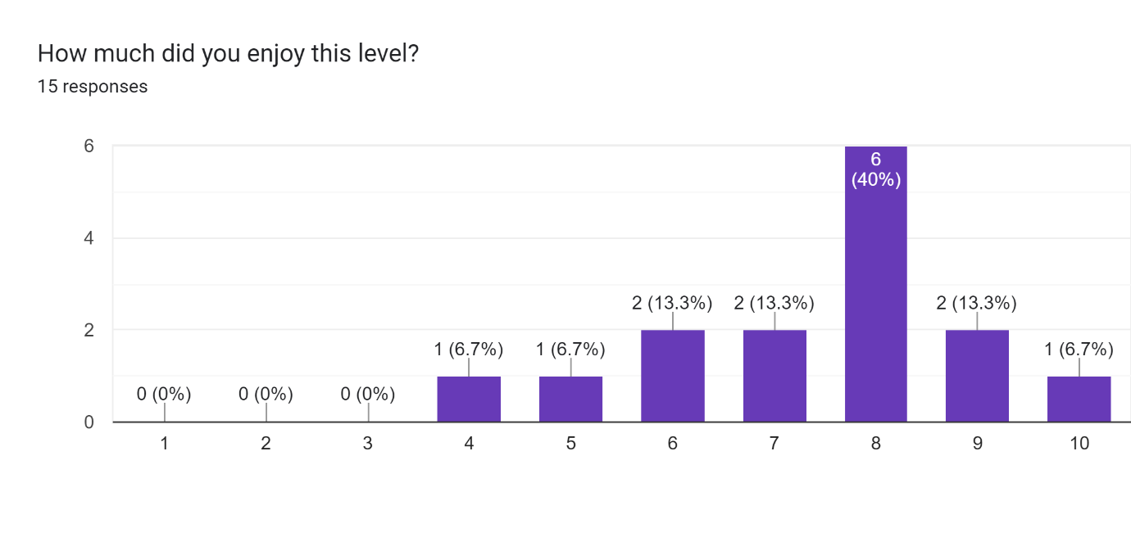

**Note:** 10 = Extremely Enjoyable, 1 = Extremely Unenjoyable

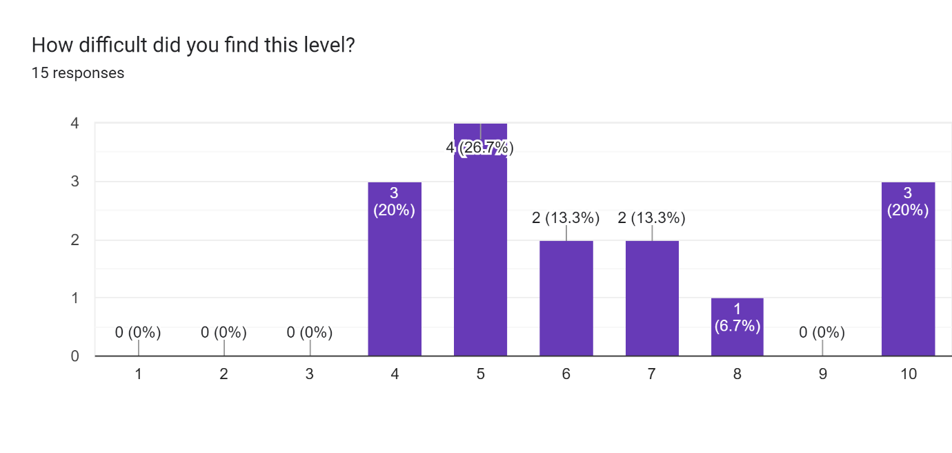

**Note:** 10 = Extremely Easy, 1 = Extremely Hard

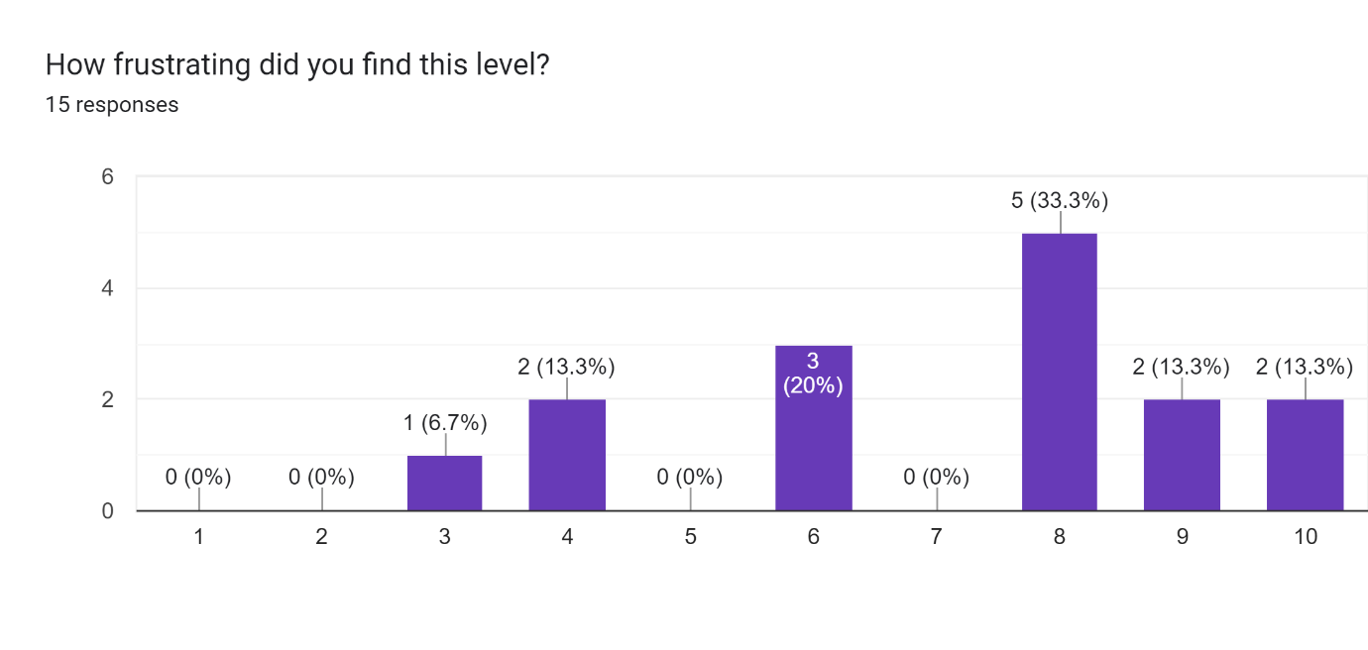

**Note:** 10 = Not Frustrating, 1 = Extremely Frustrating

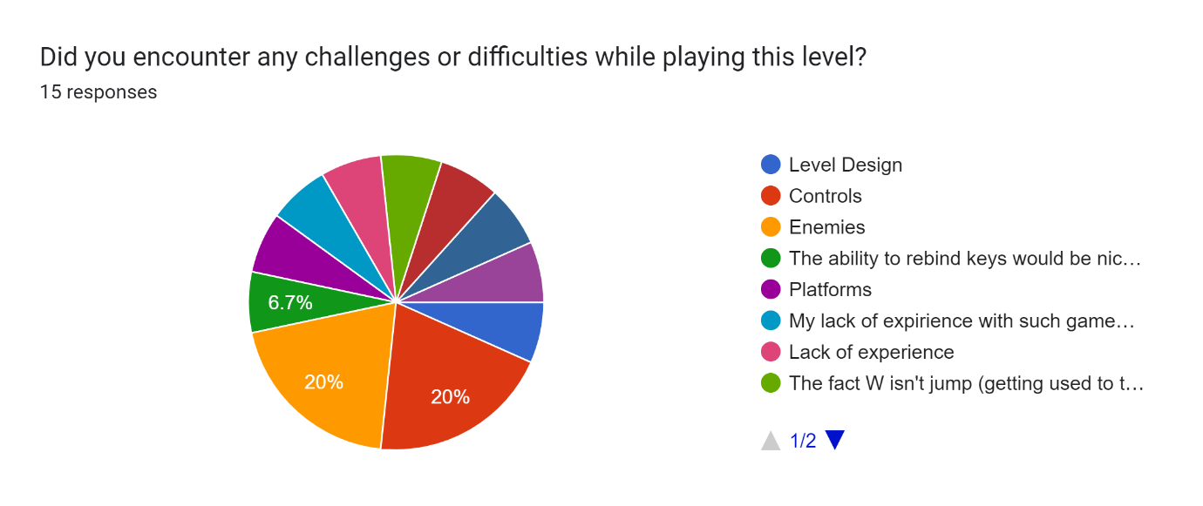

Other answers:

* ‘The ability to rebind keys would be nice as I do not use WASD typically as I am left-handed.’
* ‘Platforms’
* ‘My lack of experience with such games. If I played more of these games may have performed better.’
* ‘Lack of experience’
* ‘The fact W isn’t jump (getting used to the controls)’
* ‘Unreal’s built in momentum is a bit hard to deal with’
* ‘Timing of jumps’
* ‘Not very good at using keyboard’

##### Level 2:

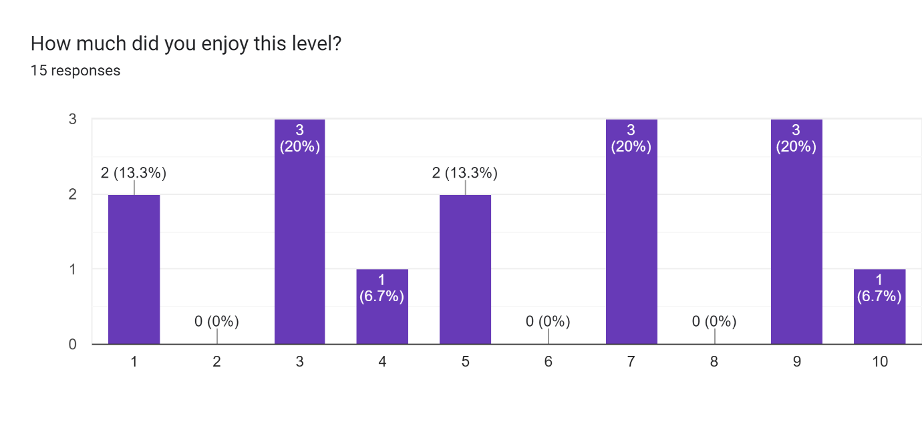

**Note:** 10 = Extremely Enjoyable, 1 = Extremely Unenjoyable

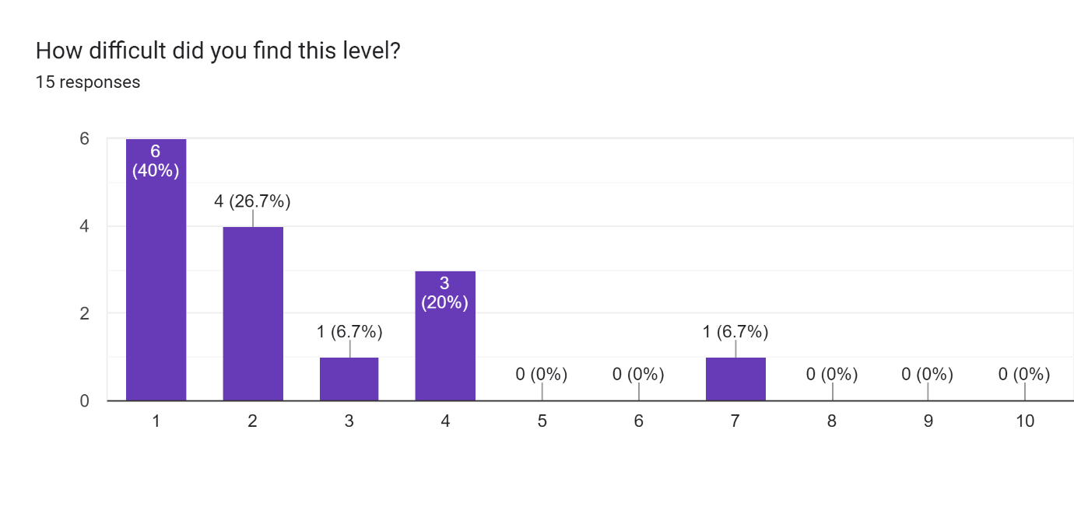

**Note:** 10 = Extremely Easy, 1 = Extremely Hard

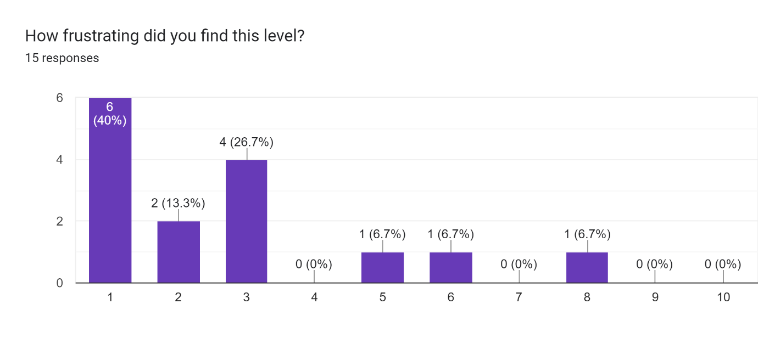

**Note:** 10 = Not Frustrating, 1 = Extremely Frustrating

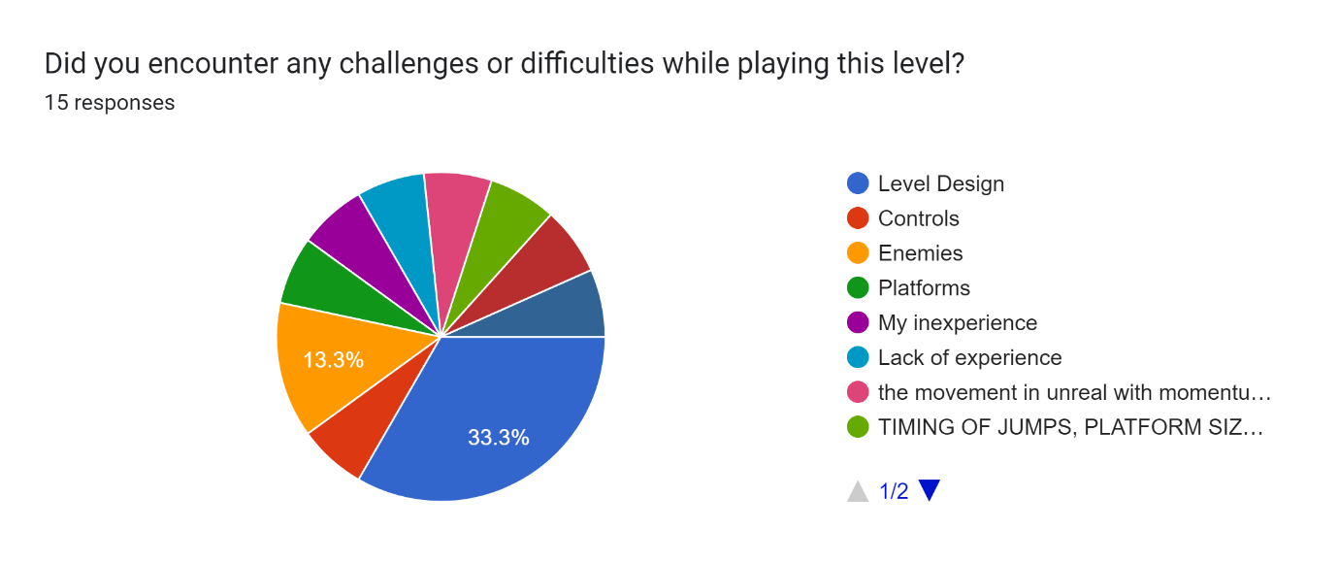

Other answers:

* ‘My inexperience’
* ‘Lack of experience’
* ‘The movement in unreal with momentum is what prevented this level from being the best. The design is intentionally hard, so I feel like this stands out more to me’
* ‘Timing of jumps, platform size changed to be smaller’
* ‘Jumps are too far apart’
* ‘Getting stuck in a loop from eagles killing me’

##### Level 3:

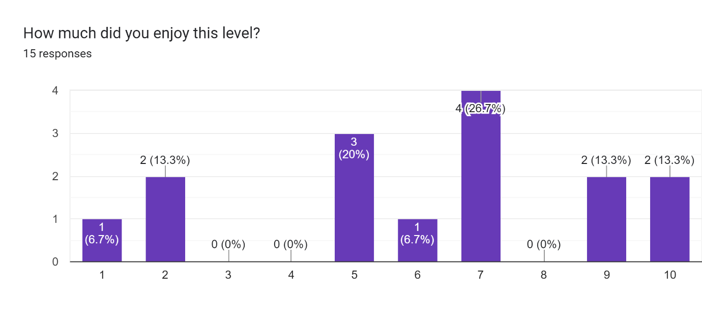

**Note:** 10 = Extremely Enjoyable, 1 = Extremely Unenjoyable

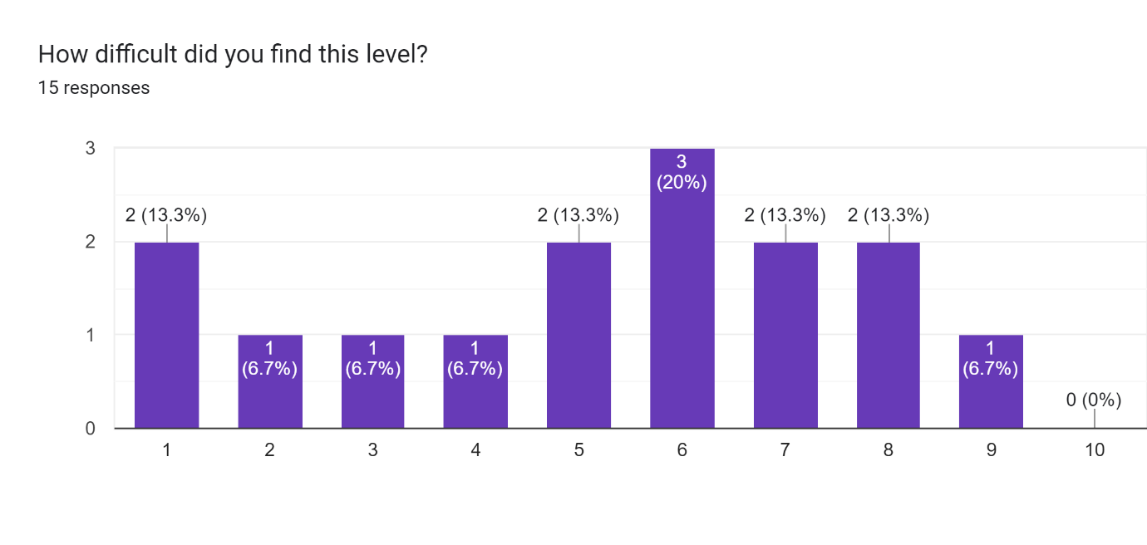

**Note:** 10 = Extremely Easy, 1 = Extremely Hard

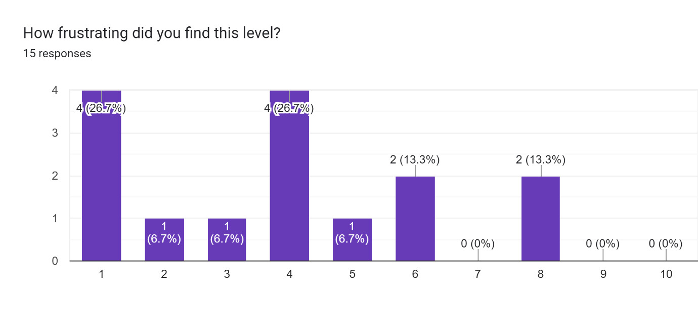

**Note:** 10 = Not Frustrating, 1 = Extremely Frustrating

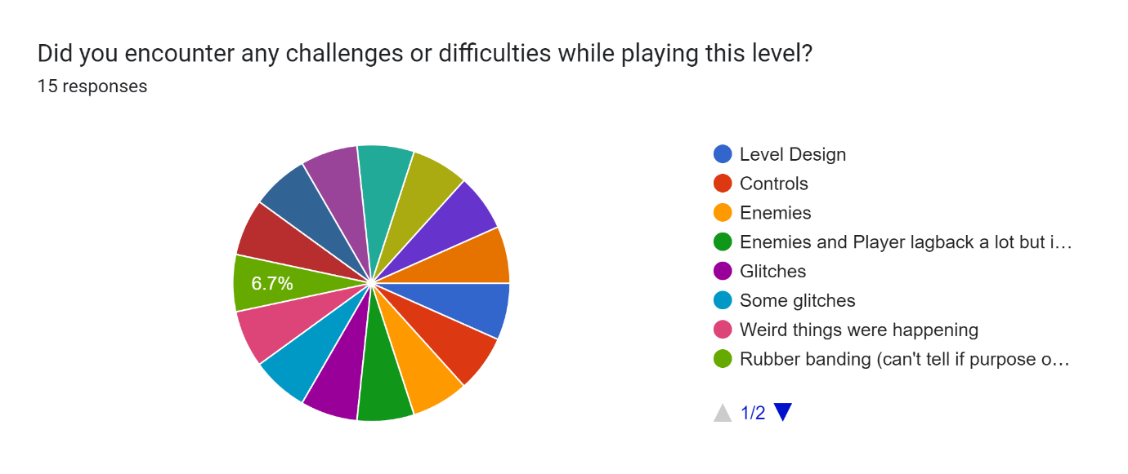

Other answers:

* ‘Enemies and player lag back a lot but it added to the challenge so it made it more fun’
* ‘Glitches’
* ‘Some glitches’
* ‘Weird things were happening’
* ‘Rubber banding (can’t tell if on purpose or not’
* ‘the glitches that seem to be built in were very frustrating’
* ‘the glitches, was a nice touch’
* ‘glitches kept making me fail jumps’
* ‘kept getting teleported into the platforms’
* ‘movement glitches although it made the level more fun in a challenging way’
* ‘Lag kept getting me stuck’
* ‘glitching while jumping’

##### General:

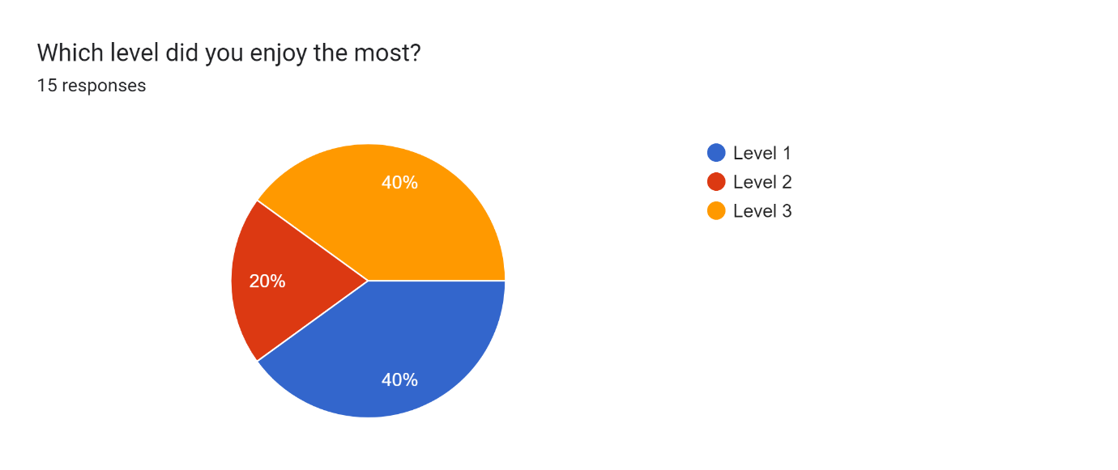

#### Individual Tests:

##### Subject 001:

###### Time:

|  |  |  |
| --- | --- | --- |
| **Level 1 Time:** | **Level 2 Time:** | **Level 3 Time:** |
| 1m 20s | DNF (2m 50s) | 2m 35s |

###### Game Reactions:

**Level 1:**  Showed little varying reactions on the first level, mostly keeping a neutral concentration face.

**Level 2:** In the second level, they showed many frustrated reactions including saying the phrase “Oh my god” out loud – usually when missing a jump. They also had a few bursts of laughter sometimes when they would miss a jump or die to an enemy.

**Level 3:** In the third level they mentioned the lag glitch once they realised it wasn’t just a one-off glitch. There were more reactions of laughter on this level and less frustrated reactions. They verbally say that they “enjoy this level more than the last one” while playing.

###### Interview:

**M)** Which level did you find the most challenging, and which part of it specifically?

**S)** Level 2, and it was the most challenging because the platforms were smaller

**M)** Do you think that hindered your ability to jump?

**S)** Yes, because you move so fast, I couldn’t make it up the third jump for like 2 minutes or something like that.

**M)** Do you feel any type of reactions while playing the levels, any emotions or anything like that?

**S)** Level 2 was definitely really annoying, um, because of that I didn’t enjoy it as much as any of the other levels. But when it came to level 3 for example even though it had glitches and stuff it added to the challenge which made it more fun for me

**M)** Were there any moments where you felt like quitting?

**S)** Yeah level 2 where I couldn’t make the jump.

**M)** What made you quit specifically.

**S)** The fact I could not make it up the same jump after 2 minutes and kept having to go back to the start.

**M)** How would you describe the balance between the challenge and enjoyment of the game?

**S)** If level 2 wasn’t there it would be quite fun, going from level 1 to 3 would be fun, but level 2 definitely added to the difficulty and frustration of the game too much.

##### Subject 002:

###### Time:

|  |  |  |
| --- | --- | --- |
| **Level 1 Time:** | **Level 2 Time:** | **Level 3 Time:** |
| 2m 22s | DNF (3m 0s) | DNF (1m 15s) |

###### Game Reactions:

**Level 1:** Had no reactions.

**Level 2:** Sighed often when failing a jump and often repositioned themselves on the chair. They started pressing the spacebar quite hard when jumping as the level went on. They also started to slowly lean further towards the screen over time.

**Level 3:** The final level was mostly met with laughter, and they quit the level very early on after only experiencing the glitches a few times. They let out a deep sigh before quitting the level.

###### Interview:

**M)** Which level did you find the most challenging, and which part of it specifically?

**S)** I found level 3 the most challenging, mainly due to the fact there was a multitude of glitches when I would try to jump on a platform, like my character would get thrown around.

**M)** Did you feel any type of reactions while playing, any emotions or such?

**S)** Ehhh…frustration. Level 3 especially when I was glitching.

**M)** Were there any points where you felt like quitting?

**S)** Yeah I quite twice *laughter*. Level 2 was uh – I thought I could do it, but level 3 I did not, so I quit straight away.

**M)** How would you describe the balance between the challenge and enjoyment of the game?

**S)** I think it was a good balance especially on level 1 but the enjoyment decreased on each level.

##### Subject 003:

###### Time:

|  |  |  |
| --- | --- | --- |
| **Level 1 Time:** | **Level 2 Time:** | **Level 3 Time:** |
| DNF (1m 20s) | DNF (1min 0s) | DNF (2m 2s) |

###### Game Reactions:

**Level 1:** Let out a heavy sigh every time they failed a jump. Gave up on the level quickly.

**Level 2:** Asked again if they were allowed to give up. Gave up extremely quickly after not being able to do the first jump.

**Level 3:** Commented that the level was ‘weird’. Gave the level a bit longer of a try but still gave up after a few glitches affected them.

###### Interview:

**M)** Which level did you find the most challenging, and which part of it specifically?

**S)** Probably the first level.

**M)** And why was that?

**S)** The controls, they felt a bit dodgy.

**M)** Did you feel any type of reactions while playing, any emotions or such?

**S)** Frustration.

**M)** Were there any points where you felt like quitting?

**S)** Yes.

**M)** When?

**S)** Whenever I kept failing the jumps. They felt very difficult.

**M)** How would you describe the balance between the challenge and enjoyment of the game?

**S)** It felt too difficult, especially with the controls.

##### Subject 004:

###### Time:

|  |  |  |
| --- | --- | --- |
| **Level 1 Time:** | **Level 2 Time:** | **Level 3 Time:** |
| 2m 33s | 12m 15s | DNF (1m 40s) |

###### Game Reactions:

**Level 1:** No reactions, complete the level with relative ease.

**Level 2:** Scrunching of the face during difficult jumps. Some verbal reactions such as going “oooh” when doing big jumps. Some smiling upon completing a hard section. Threw themselves back on the chair upon completing the level and letting out a sigh of relief and a smile.

**Level 3:** Gave puzzled faces when the glitches occurred, and gave up quite quickly after failing a few jumps to them.

###### Interview:

**M)** So which level did you find the most challenging, and which part was the most challenging?

**S)** Level 2.

**M)** And which part?

**S)** The drop-down bit, you know where there are the two floating platforms, and you have to drop down. Once I got there though it was alright.

**M)** Did you feel any type of reactions while playing, any emotions or such?

**S)** Slight annoyed with myself, but also gobsmacked I manage to beat the second level *laugh*.

**M)** Were there any moments where you felt like quitting?

**S)** Yeah, when I fell off the world and got taken back to the starting point.

**M)** How would you describe the balance between the challenge and enjoyment of the game?

**S)** I thought it was ok, +but I quite like a challenge in a game cause that’s what makes you keep playing. If it’s boring and just the same thing then it’s just boring.

##### Subject 005:

###### Time:

|  |  |  |
| --- | --- | --- |
| **Level 1 Time:** | **Level 2 Time:** | **Level 3 Time:** |
| 5m 40s | DNF (3m 15s) | 6m 24s |

###### Game Reactions:

**Level 1:** Mention that they feel like they are doing bad and jokingly talk about how if they are struggling now, then how are they going to deal with the other levels.

**Level 2:** Remained concentrated at first. Turned into an agitated look after a few minutes on the level. Lots of repeated cursing upon failing jumps or dying. Throwing themselves back on their chair on particularly frustrating failures.

**Level 3:** Lots of confusion upon experiencing the glitches. Some angry pointing at the screen when a glitch happened.

###### Interview:

**M)** Which level did you find the most challenging, and which part of it specifically?

**S)** It was level 2 because the platforms were really small, and you had to do a running jump to get on them.

**M)** Did you feel any type of reactions while playing?

**S)**. Frustration – yes, lots of frustration.

**M)** Were there any points where you felt like quitting?

**S)** Yeah, I quit in level 2 and still feel bad for it. I think if I gave myself some more time, like paused and went for a walk I could do it after that.

**M)** How would you describe the balance between the challenge and enjoyment of the game?

**S)** I thinks its good cause while its challenging but for me the challenging bit is the fun bit so if it was any easier, I wouldn’t have enjoyed it as much.

##### Subject 006:

###### Time:

|  |  |  |
| --- | --- | --- |
| **Level 1 Time:** | **Level 2 Time:** | **Level 3 Time:** |
| 2m 20s | 7m 29s | 3m 32s |

###### Game Reactions:

**Level 1:** Only reacted to not being able to jump on the enemies. Thought you would be able to kill the eagles by jumping on top of them.

**Level 2:** Laughed a bit when failing to jump from the moving platforms. Some general cursing and some “why did I do that” when failing jumps. At one point said, “oh my god why have you made this so difficult”.

**Level 3:** Statements of disbelief when the glitches messed them up such as “no way”.

###### Interview:

**M)** Which level did you find the most challenging, and which part of that level specifically?

**S)** Probably level 2, because I was s*** at it.

**M)** And why did you feel like you were s*** at it?

**S)** I just felt like the distances for the jumps were just on the edge of what was possible.

**M)** Did you feel any type of reactions or emotions while playing?

**S)** Yeah level 3 made me quite angry and frustrated, cause it kept sending me backwards.

**M)** A bit glitchy huh?

**S)** Yeah, very glitchy.

**M)** Were there any points where you felt like quitting?

**S)** No cause I’m not a quitter. *laugh*

**M)** How would you describe the balance between the challenge and enjoyment of the game?

**S)** I think it was quite a good balance to be fair.

##### Subject 007:

###### Time:

|  |  |  |
| --- | --- | --- |
| **Level 1 Time:** | **Level 2 Time:** | **Level 3 Time:** |
| 6m 36s | DNF (15m 30s) | 3m 16s |

###### Game Reactions:

**Level 1:** Staying mostly calm during the first level, occasionally hyping themselves up with comments such as “I can do this”. One particular failure of a jump made them cover their mouth in shock.

**Level 2:** Multiple frustrated groans when failing jumps. Very determined to not give up. Excited when getting to the halfway point. Only gave up after a long time of playing.

**Level 3:** Asked why they were not ‘walking properly’ and mentioned sometimes when they pressed a key they wouldn’t walk. When a lag glitch happened, they asked me what happened there. Finished the level despite not understanding the glitching.

###### Interview:

**M)** Which level did you find the most challenging, and which part of it was the most challenging?

**S)** Uh, the second one.

**M)** And why was that?

**S)** Because I kept falling off.

**M)** And why do you think you kept falling off?

**S)** Cause I wasn’t very good at it and it was quite a hard level.

**B)** And in what way was it hard?

**S)** Well, the platforms were a lot smaller.

**M)** Did you feel any type of reactions or emotions while playing?

**S)** Extreme anger. *laughs* Haha no, frustration.

**M)** Were there any points where you felt like quitting?

**S)** Yeah, in the second one.

**M)** How would you describe the balance between the challenge and enjoyment of the game?

**S)** Probably a good balance apart from the second one, maybe it was a bit too hard but that’s probably just me.

###### Subject 008:

Time:

|  |  |  |
| --- | --- | --- |
| **Level 1 Time:** | **Level 2 Time:** | **Level 3 Time:** |
| 2m 57s | 7m 4s | 1m 36s |

Game Reactions:

**Level 1:** Slight talk about confusion with controls as expected ‘W’ to be jump. Slammed hand on table when failing a jump.

**Level 2:** Lots of continuous swearing. Excitement when accomplishing a section they were stuck on. Leaned in towards the screen for most of it.

**Level 3:** General confusion and mentioned the lagging effect. Pointed to show when the lag effect happened. Kept a puzzled look on their face throughout the level.

Interview:

**M)** Which level did you find the most challenging, and which part of that level specifically?

**S)** 2.

**M)** Why?

**S)** Getting used to the momentum – were you carrying momentum? Yeah getting used to the momentum.

**M)** Did you feel any type of reactions or emotions while playing?

**S)** Anger, rage.

**M)** Were there any points where you felt like quitting?

**S)** Within the first minute and then it went away.

**M)** How would you describe the balance between the challenge and enjoyment of the game?

**S)** I’d say it was pretty balanced to be fair.

##### Subject 009:

###### Time:

|  |  |  |
| --- | --- | --- |
| **Level 1 Time:** | **Level 2 Time:** | **Level 3 Time:** |
| 1m 5s | 8m 40s | 2m 25s |

###### Game Reactions:

**Level 1:** No major reactions. Remained calm and concentrated.

**Level 2:** Mentioned how the 1x1 blocks are annoying. Mentioned how they felt like I was testing for frustration and purposely made it frustrating. When they kept failing a jump over and over they starting saying out loud: “please please let me make this jump”.

**Level 3:** Found the glitches funny and laughed at most of them. Mentioned that they liked the lag glitch specifically.

###### Interview:

**M)** Which level did you find the most challenging, and which part of that level specifically?

**S)** Umm, I have to say the level I found the most challenging was level 2, specifically the second sort of third of the level with the lack of another checkpoint to be able to keep trying at the end. It felt frustrating just having the one checkpoint.

**M)** Did you feel any type of reactions or emotions while playing?

**S)** Frustration and with some of it, some enjoyment cause some of the movement felt a bit funny. But that’s just my feeling because often if something is wonky I will tend to laugh at it anyway even if its frustrating. But with level 2 it was more hard to beat and was a different type of frustration.

**M)** Were there any points where you felt like quitting?

**S)** Umm, there was definitely a moment cause I said to myself if I got to 8 minutes I would give up. It was mainly from the annoyance of playing the same portion of the level over and over again.

**M)** How would you describe the balance between the challenge and enjoyment of the game?

**S)** Level 1 was a bit too little challenge, level 2 was way too much, but level 3 was perfect no changes needed, the glitches can stay in they were fun.

##### Subject 010:

###### Time:

|  |  |  |
| --- | --- | --- |
| **Level 1 Time:** | **Level 2 Time:** | **Level 3 Time:** |
| 2m 38s | DNF (10m 10s) | 3m 49s |

###### Game Reactions:

**Level 1:** Mostly calm but got annoyed at one jump, asking to themselves “what is happening here” when they kept failing.

**Level 2:** Started putting their head down with their hands on their head when they failed a big jump or died to an enemy. After the 6-minute mark, started sighing a lot when failing a jump. Sometimes covering their face with their hands.

**Level 3:** Confused look when glitches happened, but also widely smiling. Told themselves to “stop rushing it” when they kept failing.

###### Interview:

**M)** Which level did you find the most challenging, and which part of that level specifically?

**S)** Level 2 was the most challenging.

**M)** Whys that?

**S)** I don’t even know to be fair. I dunno why I found it so difficulty. I guess jumping to the small platforms.

**M)** Like the distance to the platforms?

**S)** Yeah yeah, I’m not that used to using WASD as well, if I was on a controller I bet I could do it.

**M)** Did you feel any type of reactions or emotions while playing?

**S)** A lot of frustration.

**M)** How come? What from?

**S)** Like having to go back after missing a jump. Like hearing the jump noise and just slightly missing it then having to get all the way back afterwards. It was very unforgiving.

**M)** Were there any points where you felt like quitting?

**S)** I mean I did quit the second level because it was too frustrating. *laugh*

**M)** How would you describe the balance between the challenge and enjoyment of the game?

**S)** It’s a pretty good balance to be fair. Its like a challenge you got to keep doing it to get there. The second level was way harder than the third.

##### Subject 011:

###### Time:

|  |  |  |
| --- | --- | --- |
| **Level 1 Time:** | **Level 2 Time:** | **Level 3 Time:** |
| 4m 03s | 12m 12s | 5m 47s |

###### Game Reactions:

**Level 1:** Initial struggle to understand where to go in the level. Concentrated look for the whole level.

**Level 2:** Lots of cursing throughout the whole level. Aggressively pressing the space bar when trying a jump they had failed many times. Many frustrated sighs and groans when failing a jump or dying. When getting really frustrated they kept rushing and started failing simple jumps that they had made many times before.

**Level 3:** Confused at first but found most of the glitches amusing. Slight annoyed face when the lag glitch put them through a moving platform causing them to fall.

###### Interview:

**M)** Which level did you find the most challenging, and which part of that level specifically?

**S)** Umm, definitely level 2. I think level 3 might’ve been harder if it was before level 2 as I felt I had gotten used to the game then. The platforms were annoyingly placed in level 2 and should be moved closer.

**M)** Did you feel any type of reactions or emotions while playing?

**S)** *laugh* Yeah definitely anger on that second level when I kept messing up jumps. The teleporting in level 3 was frustrating at times too.

**M)** Were there any points where you felt like quitting?

**S)** Level 2 as I kept failing what should’ve been simple jumps because I kept rushing it.

**M)** How would you describe the balance between the challenge and enjoyment of the game?

**S)** Pretty decent but I think the levels should maybe be reordered as the difficulty spike from level 1 to 2 was a bit crazy.

##### Subject 012:

###### Time:

|  |  |  |
| --- | --- | --- |
| **Level 1 Time:** | **Level 2 Time:** | **Level 3 Time:** |
| 7m 34s | DNF (10m 13s) | 5m 2s |

###### Game Reactions:

**Level 1:** Had difficulties using the controls and explained that they were only used to using the arrow keys. Played very slow and calm. A slight bit of agitation shown when failing to jump from the moving platforms.

**Level 2:** Struggled to get to the first checkpoint. Got very annoyed with the fast-moving platforms. Lots of cursing and throwing their hands up in the air when they failed a jump.

**Level 3:** Short confusion with the glitches. Asked if “that was supposed to happen”. A bit annoyed from lagging on top of an enemy.

###### Interview:

**M)** Which level did you find the most challenging, and which part of that level specifically?

**S)** The second one was really hard. The platforms were way too fast, and the jumps got a bit annoying.

**M)** Did you feel any type of reactions or emotions while playing?

**S)** I think I got quite angry. *laugh*

**M)** What made you so angry?

**S)** Just the whole of level 2 I think, I kept falling over and over on the same jumps. I think I’m just bad at jumping games though.

**M)** Were there any points where you felt like quitting?

**S)** I did on level 2 so yeah.

**M)** What pushed you to quit?

**S)** I just knew I wouldn’t be able to do it. *laugh* I couldn’t get past this one jump.

**M)** How would you describe the balance between the challenge and enjoyment of the game?

**S)** Umm, maybe a little bit too hard? Level 3 was more fun and not as hard than the second one so maybe make it more like that one?

##### Subject 013:

###### Time:

|  |  |  |
| --- | --- | --- |
| **Level 1 Time:** | **Level 2 Time:** | **Level 3 Time:** |
| 2m 50s | 5m 59s | 2m 44s |

###### Game Reactions:

**Level 1:** No notable reactions to anything in the first level.

**Level 2:** Let out a small chuckle when coming up against their first challenging jump. Kept a concentrated face for the whole level.

**Level 3:** Paused for a little bit upon their first encounter of a glitch. Also asked out loud if something was wrong with the movement. Understood the glitches quite quickly and finished the rest of the level quickly.

###### Interview:

**M)** Which level did you find the most challenging, and which part of that level specifically?

**S)** I guess level 3? Level 2 was hard but the glitches of the third level were a bit unpredictable. I did like the simulation lag one though, it was fun.

**M)** Did you feel any type of reactions or emotions while playing?

**S)** Is concentration a reaction? I guess I was like in focus mode for most of it if that counts.

**M)** Were there any points where you felt like quitting?

**S)** Uh no, not really.

**M)** How would you describe the balance between the challenge and enjoyment of the game?

**S)** It was pretty fair. Maybe a bit of whiplash going from the first to second level.

##### Subject 014:

###### Time:

|  |  |  |
| --- | --- | --- |
| **Level 1 Time:** | **Level 2 Time:** | **Level 3 Time:** |
| 3m 59s | (DNF) 9m 43s | 4m 13s |

###### Game Reactions:

**Level 1:** Some confusion on where to go initially. Relaxed look on their face.

**Level 2:** Started pressing the keyboard keys down really hard once they started getting stuck on a jump. Some cursing as well. Asked me if a jump they were stuck on was actually possible. Gave up after being stuck on it for a while. Disappointed look on face once started to fail.

**Level 3:** Kept a puzzled look the whole level. Started leaning in towards the screen once they noticed the glitches.

###### Interview:

**M)** Which level did you find the most challenging, and which part of that level specifically?

**S)** The second level for me. I gave up cause I don’t think I could’ve beaten it.

**M)** Which part pushed you to give up?

**S)** That big jump in the second half after the moving platforms. It was too far, and I kept falling.

**M)** Did you feel any type of reactions or emotions while playing?

**S)** Stressed I guess, I really wanted to finish every level.

**M)** Were there any points where you felt like quitting?

**S)** Level 2, cause I did quit. *laugh*

**M)** How would you describe the balance between the challenge and enjoyment of the game?

**S)** Maybe a bit too hard? I think level 2 should be a bit easier.

##### Subject 015:

###### Time:

|  |  |  |
| --- | --- | --- |
| **Level 1 Time:** | **Level 2 Time:** | **Level 3 Time:** |
| 2m 45s | 6m 13s | 3m 1s |

###### Game Reactions:

**Level 1:**  Looks a bit confused when they tried to jump on top of an enemy and died instead of killing it.

**Level 2:** Initial smirking when faced with the difficulty, but turned to a concentrated look once they started failing some jumps. Started staring intensely and didn’t blink much while leaning into the screen. Some under the breath cursing when dying to an enemy.

**Level 3:** Amused look when faced with the glitches. Laughed whenever the lag glitch happened. Seemed confused by the input glitch and kept aggressively pressing movement keys.

###### Interview:

**M)** Which level did you find the most challenging, and which part of that level specifically?

**S)** Level 2 I’d say. That had some really stupid platform placement – it felt impossible at time. I really had to jump at the last frame to get over some of them.

**M)** Did you feel any type of reactions or emotions while playing?

**S)** I had some confusion with the last level.

**M)** Why’s that?

**S)** Well, I’m guessing you’ve made it glitchy right? But I’m not sure which were intentional, and I think you messed with the controls for it too cause they felt inconsistent.

**M)** Were there any points where you felt like quitting?

**S)** Not really, no.

**M)** How would you describe the balance between the challenge and enjoyment of the game?

**S)** Decent. Level 2 might need some tweaking though to the platforms.